New USPS Priority Mail Rates
On September 7, 2014 the USPS Rates for Priority Mail experienced an increased. Priority Mail is based on weight and location .Below is a chart with the new Flat Rate Prices. UAH applies Commercial Base Rates Prices so some locations may be discounted. If you have any questions please call Mail Services @ 265-824-6116.
Examples of Priority Mail Changes:
Note: The price changes vary by price cell and price tier.
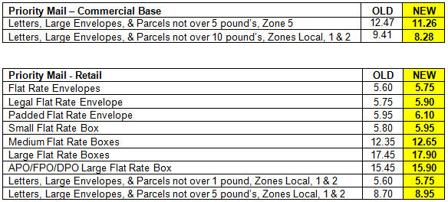
Thank You,
Mail Services

