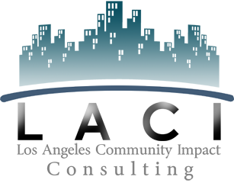

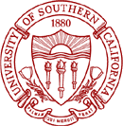

Client Application 2014-2015

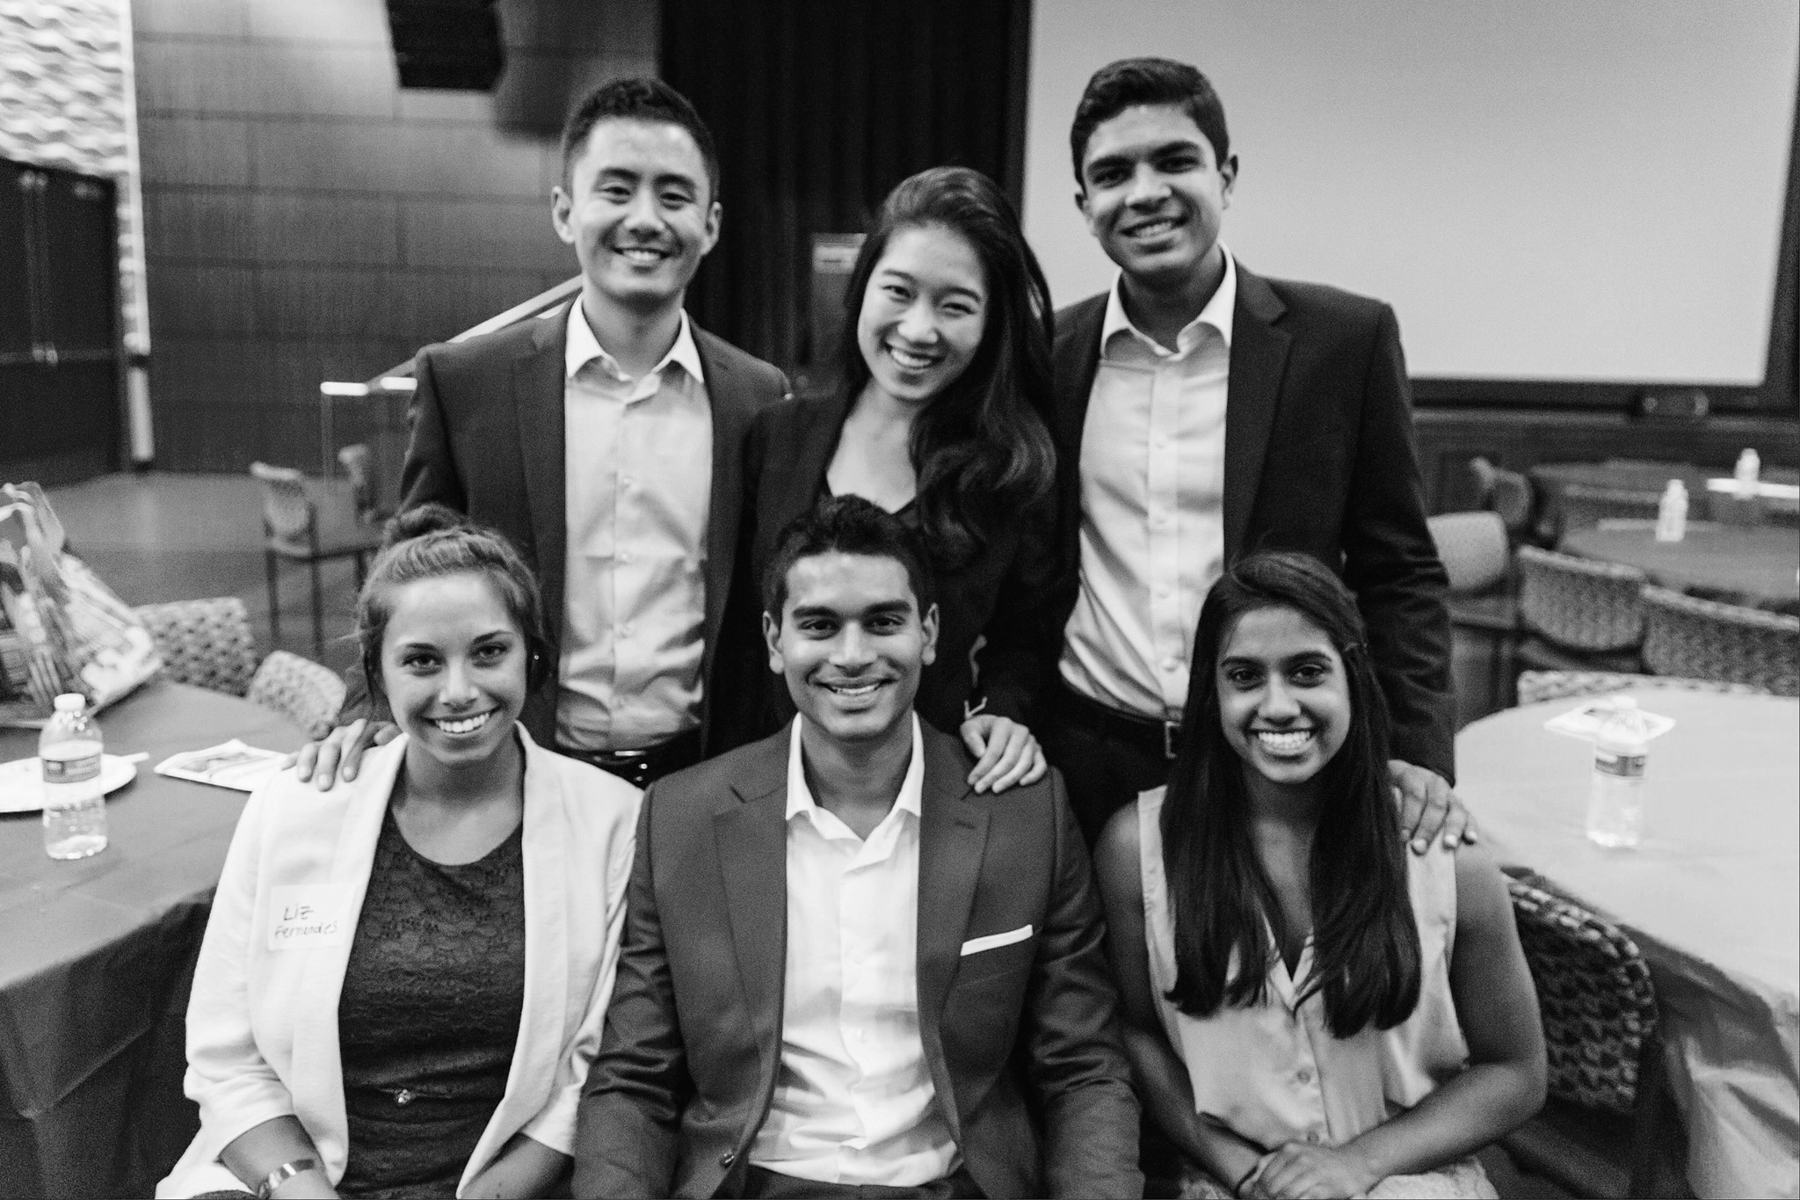

“Our original problem definitely was a very tough issue to deal with and while it is difficult for most to adapt to change, **LACI students were able to respond to our organization’s changing needs.” —Breathe LA**

“I enjoyed how the team **grasped the mission of my work** and embraced it as they tackled their project. I enjoyed collaborating with them and together grappling with some of the big questions. I enjoyed their fresh ideas and thoughtfulness.” **—Project Inspiration**

**Most Outstanding Organization 2009, 2010**

**Student’s Choice Organization of the Year 2009**

**Best Student Organization Nominee 2010**

Recognition & Awards

After ten years of working with the Los Angeles community, we have found that clients and students that work closely together typically produce more successful recommendations. Below are the standards that we hold our teams to and have found promote the development of a strong deliverable.

**Project Deliverables:** Our students are equipped to tackle business problems on an organizational level. Through client interviews and primary and secondary research, our teams provide specific, actionable recommendations that allow clients to improve and grow their organization. However, our teams are not suited for implementation projects, which would be better executed by interns or employees.

**Confidentiality Policy:** In order to analyze a client’s needs, students often need specific resources from a client. For example, a team tasked with creating a marketing plan may need sales records, cost information, and other pertinent documents. We promise our clients full confidentiality in return: no sensitive information will be released to the public or shared with other USC organizations.

**Client-student Communication:** On average, we expect our teams to meet with their client in person once every two weeks while maintaining other forms of communication (phone, email, etc.) at least once a week, although clients and their team may decide to maintain more frequent communication. Both students and clients should respond to communication within two business days of receipt.

What to Expect from LACI

Los Angeles Community Impact (LACI) is a University of Southern California student organization that strengthens non-profits and small businesses in the Los Angeles area by addressing their business-related challenges. Established in 2004, LACI improves the Los Angeles community through pro bono consulting while simultaneously fostering the personal and professional growth of the next generation of business leaders through service learning.

As a LACI client, your organization will be paired with a team of 4-5 competent, energetic USC undergraduates dedicated to your project. These teams are backed by extensive resources, including the expertise of USC Professor Mentors and the LACI Executive Board. Over the span of three months, your team of student consultants produces a written deliverable and presentation that provides recommendations and solutions for a specific project. Types of projects vary in order to target our client’s most pressing challenges, including marketing plans, market research, expansion plans, and financial analysis.

About Los Angeles Community Impact

**Los Angeles Community Impact, 2014-2015 Application**

Below are a few projects that exemplify the various challenges LACI tackles and the type of structure we develop in our teams. However, LACI accepts many other kinds of projects beyond the ones listed below, so please do not feel limited to these project ideas.

**LA’s Best:**

Connecting for Success is a staff development program that introduces new and innovative ways of working with

youth to challenge them to think about their attitudes towards their peers, families and communities and to learn

about how they can empower themselves to make an impact locally and globally.

***Key Project Question:***

How can LA’s BEST maximize success for its Connecting for Success curriculum?

***Key Recommendations:***

• Conduct an experimental study on CFS to generate evidence for its effectiveness

• Develop video training to make the product ready for sale

• Approach a big buyer like the Boys and Girls Club and YMCA to make a high-volume sale

• Create a partnership with the Developmental Studies Center to sell and distribute the curriculum

**Avenue 50:**

Avenue 50 Studio is a multicultural alternative art space, with an emphasis on Chicano/Latino art.

***Key Project Question:***

How can Avenue 50 address its decline in visitors, which in turn affects the art studio’s revenue streams?

***Key Recommendations:***

• Positional shift to highlight cultural significance of the gallery and emphasize the educational benefit of art, all while continuing to support art sales

• Expand cultural focus beyond Chicano art

• Provide greater educational opportunities with art and the gallery itself

• Establish Avenue 50 as a stand-alone cultural destination in Los Angeles

• Increase capabilities and mechanisms to promote art sale

**Habitat for Humanity:**

Habitat for Humanity is a non-profit organization that tackles the issues of poverty housing all over the world. Nickels

for Nails is a Habitat for Humanity fundraising program that encourages individuals to make a difference by donating

extra nickels (as well as pennies, dimes, quarters, and dollars).

***Key Project Question:***

How should Habitat for Humanity re-structure its Nickels for Nails program to make it a self-standing,

signature HFH program that fulfills its stated objectives?

***Key Recommendations:***

• Target two segments: Elementary Schools and Middle/High Schools

• Choose a program category and implement a 3-pronged structure

• Brand NFN as a fun and engaging youth-driven fundraiser with social-cause based activities

• Implement a proactive marketing approach and develop a centralized marketing platform

Examples of Previous Projects



**Application Information**

Because of the number of organizations looking to work with LACI, a selection process is necessary. Also, to ensure that each project presents a good learning experience for LACI members, we must turn down projects focused simply on implementation or better suited for a full-time work force. LACI typically works with 13-14 clients per semester.

Please email your completed application to [laci.projects@gmail.com](mailto:laci.projects@gmail.com) before **midnight on Friday August 1st, 2014**. LACI will review all project applications on a rolling basis and selected applicants will be invited to an on-campus**.** If you or someone from your organization is not able to make this interview date, the Projects team will make exceptions on a case-by-case basis. Because applications are processed on a rolling basis, those that submit their applications earlier will be more likely to be invited to interview and more likely to receive their preferred interview date/time.

**Part I – Basic Information**

|  |  |  |  |
| --- | --- | --- | --- |
| **Contact Person** | | | |
| Name: |  | Position: |  |
| Email: |  | Phone: |  |
| What is your educational and professional background? | | | |
|  | | | |
| How did you hear about LACI? | | | |
|  | | | |

|  |  |  |  |  |  |  |
| --- | --- | --- | --- | --- | --- | --- |
| **Organization** | | | | | | |
| Name: |  | | | | | |
| Address: |  | | | | | |
| City: |  | | State: |  | Zip: |  |
| Semester (Fall or Spring): | |  | Founded (Month, Year): | | |  |
| Estimated Operating Budget: | |  | Number of Employees | | |  |
| Website: | |  | | | | |

**Part II – Organization-Focused Questions**

1. **Please state your organization’s mission statement:**
2. **Please briefly describe your organization’s history in relation to executing its mission statement:**
3. **What community does your organization serve, and how does it benefit and support them?**
4. **Please briefly describe the average day-to-day operations at your organization:**
5. **What are your organization’s overarching short-term goals? Please list them from most important to least important.**
6. **What are your organization’s overarching long-term goals? Please list them from most important to least important.**
7. **What steps (if any) has your organization taken to achieve these goals?**

**Part III—Project Specific Questions**

1. **What key challenges does your organization face and how do they affect your ability to execute your organization’s mission statement?**
2. **What organizational resources or expertise are you lacking in addressing these challenges?**
3. **What would you like to see in a final recommendation from a LACI team? For example, which of the challenges outlined above would you like the team to address? Please refer to the past project descriptions outlined in the introductory section of this application for some guidance as to what you can expect from a team.**

**Part IV—Scheduling Questions**

Given that LACI requires a regular commitment for about 12 weeks, this section looks to assess your availability and desired level of commitment over the course of the semester. Clients should expect to be in contact with their LACI team via email or phone on a weekly basis and in- person meetings on a bi-weekly basis.

1. **Who from your organization will be the primary contact for the LACI team and what role does s/he serve in your organization?**
2. **How often will s/he be able to meet with your LACI team? Please review expectations as to how often we would like to meet with our clients.**
3. **What days and times are best for meeting with the LACI team (include weekends)?**
4. **Is the primary contact planning any trips out of town between August and December?**

Thank you for taking the time to fill out this application; we appreciate your interest in LACI! Again, if you have any questions, please feel free to contact Ravi Bhatt, LACI VP of Projects, by email at laci.projects@gmail.com.