Aloha, Ernie

It is with the greatest of sadness that we share the news of the passing of our dear friend, Ernie.

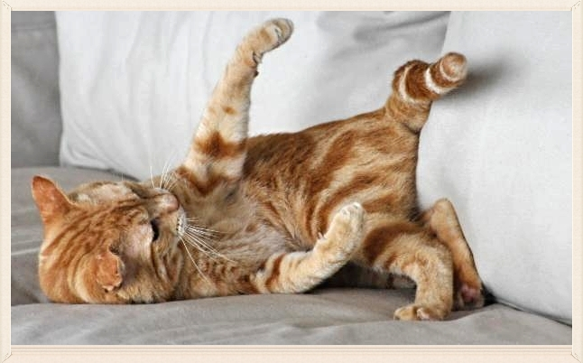

As you likely know, Ernie was a staunch supporter of Santé D'Or. He had twice donated his house in Hawaii for a drawing to benefit our animals! With his pal Rudy-toot, he also gave a challenge grant that sparked many new people to sign up for Race for the Rescues team last year.

He is survived and missed beyond words by his mom and dad, his best friend Rudy... and a Peacock who recently had its young on their Hawaii property.

He was simply a joy on this earth who gave unconditionally and shared cuddles with all of those who had the privilege to know him. If you want to make a donation in his memory, we know he would be pleased to have it go toward the Pearl Fund to help us provide medical care to our senior animals in his honor.

Thank you for being our friend, Ernie. Safe travels to you, and Aloha.

