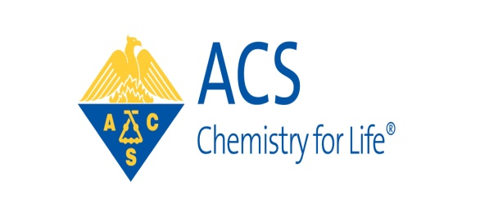

American Chemical Society - Greater Houston Section

2014 Awards Dinner
American Chemical Society - Greater Houston Section
P. O. Box 66181
Houston, Texas 77266
November 3, 2014

Dear ACS Member:
The recipients for the ACS- GHS Younger Chemist Award; Dr. Catherine Faler; Excellence in Two Year College Teaching Award, Dr. Dolores Aquino and the Greater Houston Section Award, Dr. George Hiraski will be honored. Dr. Hiraski will also give a brief seminar. The event will occur on Wednesday, December 3, 2014 starting at 6 p.m. with a social hour at the Houston Engineering and Scientific Society (H.E.S.S.) Club located at 5430 Westheimer Rd Houston, Texas 77056. Dinner will be served at 7 p.m.

The American Chemical Society – Greater Houston Section (ACS-GHS) will also honor its members who have received local, regional and national ACS awards including 2014 ACS Fellow, Richard Wilson, University of Houston. Recipients of the 2014 Stanley C. Israel Regional Award for Advancing Diversity in the Chemical Sciences, Carolyn Burnley and the 2014 E. Ann Nalley Southwest Regional Volunteer Service Award, Professor Mamie Moy will also be honored as well as Greater Houston Section members celebrating 50 and 60 years of ACS membership.

Dinner tickets cost $45.00 for all ACS members and $50.00 for anyone else who would like to join you for this special occasion. We will make a special effort to ensure that you are seated with or near your guests. To purchase tickets, please make a check or money order/cashier check payable to ACS-GHS and mail it to ACS-GHS, P.O. Box 66181, Houston, Texas 77266. You may also purchase tickets online via PayPal (Please refer to November newsletter or acs-ghs website). The deadline to purchase a dinner ticket (s) is Tuesday, November 25, 2014. Tickets will not be issued for this event but all paid reservations will be held for check in on the night of the event. The attire is business casual.
Table (8 persons) sponsorship is available starting at $350 each. Please provide a guest list when purchasing a table. The proceeds from this event will be used to support the Project Seed program and mentoring activities for members of the Younger Chemists Committee.
Please plan carefully. No tickets will be sold at the door. Self parking is available at no cost.

Sincerely,

Kerry K. Spilker
2014 ACS-GHS Awards Chair

American Chemical Society - Greater Houston Section

2014 Awards Dinner

Wednesday * December 3, 2014 * 6 p.m.
HESS Club * 5430 Westheimer Rd* Houston, Texas 77056
_ Please reserve _____ GOLD Tables(s) for $1000.00
Premium seating for 8 guests

_ Please reserve _____ SILVER Table(s) for $500.00
Preferred seating for 8 guests

_ Please reserve _____ BRONZE Table(s) for $350.00
Priority seating for 8 guests

_ Please reserve _____ INDIVIDUAL ticket(s) for $45.00 for ACS members and
$50.00 per non-ACS members
_ I am unable to attend, but would like to contribute $ ____________________
_ I would like to make a gift in tribute or in memory of ____________________

Enclosed is my check or money order made payable to ACS-GHS for $___________________
Please complete this form and mail a check or money order by Tuesday, November 25, 2014 to:
ACS - GHS
P.O. Box 66181
Houston, Texas 77266
Or register through PayPal sent in separate invitation (LINK) and also available on website
________________________________________________________________________
Donors, if desired, please provide the following information and your company logo (if available) so that you will be listed as an event sponsor on the ACS-GHS website:

Name/Title___________________________________________________________________
Company____________________________________________________________________
Address_____________________________________________________________________
City, State, Zip________________________________________________________________
Phone_________________Fax_________________Email_____________________________

ACS-GHS is a 501 (c) (3) non-profit organization. Proceeds will benefit Project Seed Intern program and the mentoring activities of the Younger Chemists Committees. Donations are deductible beyond benefit, the fair market value (FMV) of the dinner ticket is $30.00.

American Chemical Society - Greater Houston Section

2014 Awards Dinner

Wednesday * December 3, 2014 * 6 p.m.
HESS Club * 5430 Westheimer Rd* Houston, Texas 77056

2014 Guest List
If desired, Please return this list with the names of guests that will be seated at your table. Thank you.
Guests

