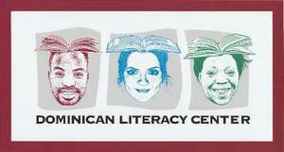
Witness Gospel Joy in Detroit
Wednesday, February 26 11:00am-3:30pm
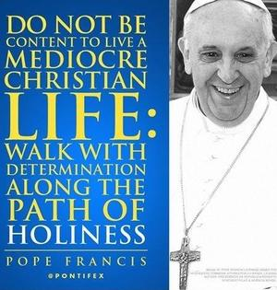
In Pope Francis’ exhortation Evangelii Gaudium – Joy of the Gospel -- he calls on Catholics “to embark upon a new chapter of evangelization marked by (Christ’s) joy” (3). Pope Francis warns us that “whenever our interior life becomes caught up in its own interests and concerns, there is no longer room for others, no place for the poor” (3). You are invited to make time for others by visiting two ministries in Detroit: Mercy Education Center and the Dominican Literacy Center.
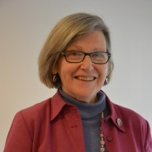
Be a Witness to Gospel Joy
Join NETWORK Executive Director and leader of NETWORK’s Nuns on the Bus Sister Simone Campbell in learning about ministries that embody the Gospel Joy every day. RSVP for one or more of the events below at www.network-education.org/JoyoftheGospel

11:00am-11:45am Visit Mercy Education Project
Join Sister Simone in learning about Mercy Education Project’s ministry of moving women and girls toward increased self-sufficiency. The Mercy Education Project is located at 1450 Howard St, Detroit, MI.

12:00pm-1:30pm Join Mercy Education Project for Lunch
Spend time getting to know each other over lunch. Note: Sister Simone will join a small group visiting the Cabrini Clinic. Due to respect for the Clinic's patient privacy concerns, we cannot open the visit to the Clinic to a large group.

2:00pm-3:30pm Visit the Dominican Literacy Center
Join Sister Simone in listening to adult learners about how gaining literacy enriched themselves, their families, and their employers. The Center is at 11148 Harper Ave, Detroit, MI.

At 6:30pm, Sister Simone will speak on "The Reality of Poverty and Political Paralysis." The event is hosted by the Pontiac Area Vicariate and is open to the public. Learn more about this event at pontiacareavicariate.org

Bear Witness to the Gospel Joy
Go to www.network-education.org/JoyoftheGospel for additional invitations to live out Joy of the Gospel. There, you’ll also find information on how to get involved in the ministries of Mercy Education Project and the Dominican Literacy Center.

