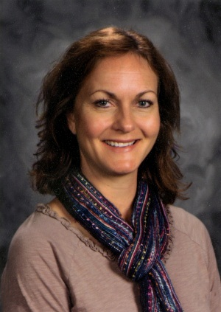
Teacher Feature
Ms. Lori Hodge
2nd grade teacher at Riverside Elementary in Brainerd, MN
Ms. Hodge was the 2014 Minnesota Excellence in Teaching with Agriculture Award winner! She represented Minnesota at the National Agriculture in the Classroom Conference in Hershey, PA June 23-27, 2014.

How are you helping students gain appreciation and understanding of agriculture and its impact on their daily lives?
I am advancing agricultural literacy in my classroom first and foremost by having an agricultural focus in every subject. Agriculture is not an additional topic, but a focus that I build into all core subjects.

Describe a successful agricultural literacy program that has benefited you students.
Partners in Active Learning Support (PALS) is a mentoring program that matches FFA members with elementary students. The high school PALS mentors teach young students about agriculture as well as serving as positive role models. The “Big Pals” meet with our “Little Pals” monthly to enrich the agricultural experience for the 2nd graders.

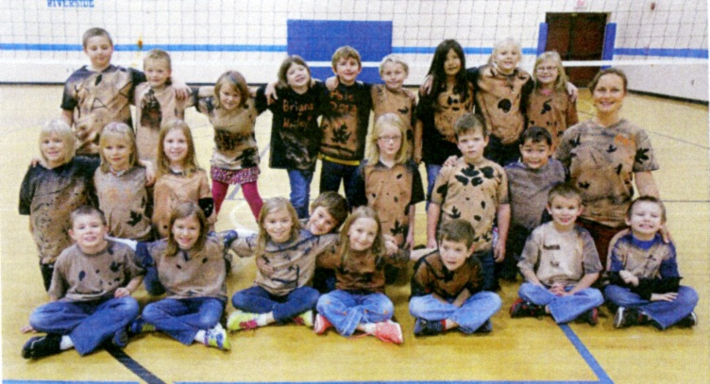
The first PALS lesson of the year provides an opportunity for students to identify natural resources in our environment and also strengthen their writing skills. The Big and Little Pals gather natural items such as leaves, sticks, or rocks to reinforce science standards focused on observations and discussions of plants, animals and natural resources. The natural items are used to create their own “one of a kind design” T-shirt. The shirt is worn with pride each PALS visit and they love to tell how it was handmade! The Little Pals also create a journal made with recycled paper and held together by a rubber band and a stick. This serves as a journal between the Big Pal and the Little Pal. There is such a sense of purpose in writing to their PAL and my kids are constantly asking when they can write back and if they can write more than the required amount. The students don’t even know they are working towards the Common Core Writing Standards. Wow is it rewarding to watch their enthusiasm to learn about their Big PAL and infuse agriculture at the same time!

As a culminating activity in May, my 2nd graders get to be the teachers while mentoring kindergarten and preschool children as they do “Farm Tours”. This is a day where the Big Pals and Little Pals present information on a specific farm animal to the younger children. After researching an animal or farm machine, they create a visual aid, and an oral presentation to teach the younger children. The actual animal or machine is provided by the High School “Big Pal” as is their support for any questions a 2nd grader may not be able to answer. This practice in public speaking is invaluable to both the Little Pal and Big Pal.

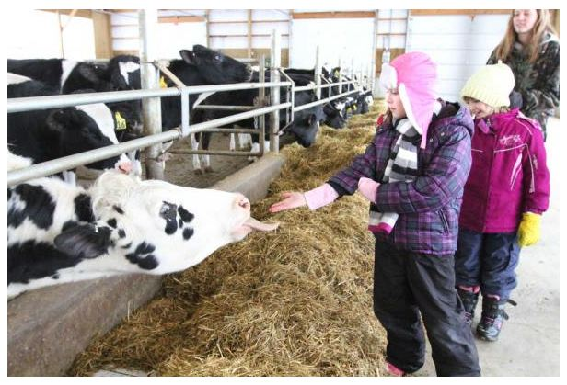
What are some examples of successfully integrating agriculture into subjects such as science, social studies, English Language arts, math and health/nutrition?
One interdisciplinary approach that I’ve used, integrates the many facets of matter with agriculture. Students learn hands-on how butter and ice cream are made with their Big Pal. The vocabulary words of solid, liquid, gas, viscous, translucent, and transparent, became part of their conversations through a memory matching game, while a trip to a local dairy farm brought it all together. They learned the math of rations for the cow’s diet, and how much milk it really takes to produce enough cheese for their pizza. Cris Peterson’s books are also a great starting point for teaching about real life on a farm. Having my own signed copy of Extra Cheese Please motivated my young writers to advance their writing to the publishing phase so they too could “sign” their work just like a real author. Following our trip to the dairy farm, my class wrote cinquain poetry. We then published the poetry book and mailed it to Caughey Farms as a thank you for the adventure on their farm.

An additional opportunity to connect agriculture and our environment is presented in the science standard that asks students to “Identify components and structural layers of the earth’s atmosphere.” What better topic to lend itself to agriculture than the weather? Growing up as a farmer’s daughter, I was reminded how much the weather affected our livelihood. Our culminating activity in this air and weather unit utilized a realistic fiction story entitled Thundercake by: Patricia Polacco. As the characters busily gather the ingredients on the farm and prepare the cake, our students learn how important each food item is and where it truly came from (not the grocery store).

Why do you believe that agricultural literacy is important to build within your students?
The impact on student learning goes beyond core subjects. I know that my students have rarely been ill on PALS days. In fact, I have had several come to school sick because they don’t want to miss seeing their pal, participating in the activities, or simply wearing their special “one of a kind” shirts. My students see a purpose in learning about agriculture when it’s integrated with the daily curriculum; just as agriculture is infused into our lives daily. They are active learners putting the content into context.

