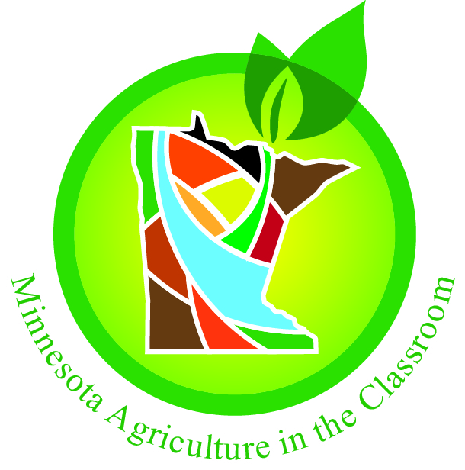
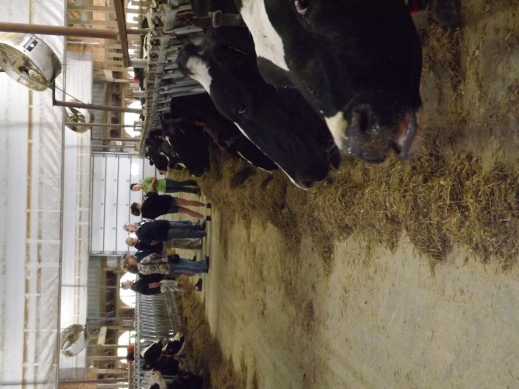
Thirty, K-12 teachers were able to gain first-hand experience and knowledge about agriculture as participants in Minnesota Agriculture in the Classroom’s (MAITC) first Summer Teacher Tour. These educators were able to observe the research, technology and labor involved in producing crops and livestock at the DuPont Pioneer Research Center in Mankato and also at Forest-Lawn Holstein Farm near Nicollet. The teachers also observed processing of agricultural products at the LeSueur Cheese Company and distribution at J & B Distribution Center in St. Michael. Finally the tour participants were able to see and hear about the process of growing grapes and making wine in our cold Minnesota climate at Sovereign Estates Wine near Waconia. Minnesota Corn Growers Association representative Cara Soper and Minnesota Commissioner of Agriculture Dave Frederickson were also able to address the group and engage in discussions with the teacher participants. Agricultural focused lesson ideas and activities, and additional resources were shared with the educators to ensure that they are able to embed agricultural literacy concepts in their curricula and classrooms.
We are extremely appreciative and grateful for support from the Minnesota Corn Growers Association and the MAITC Foundation. We hope to continue this educational professional development opportunity for many years into the future.
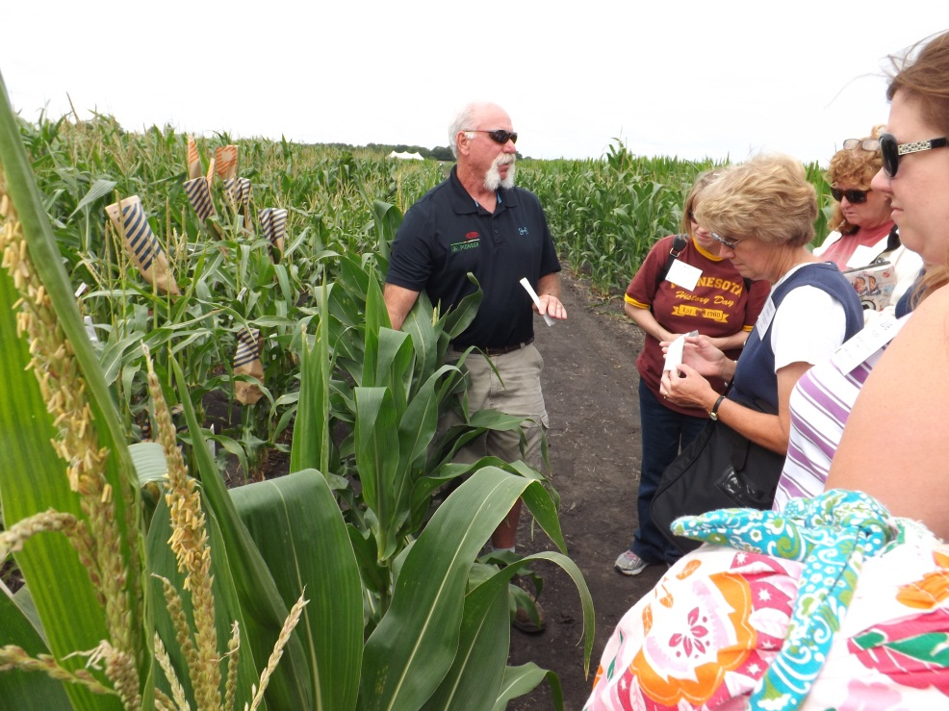
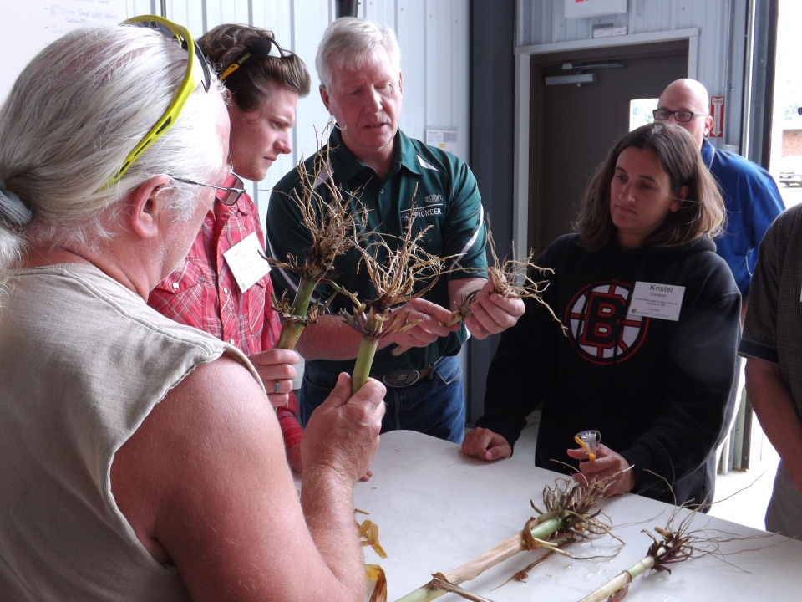
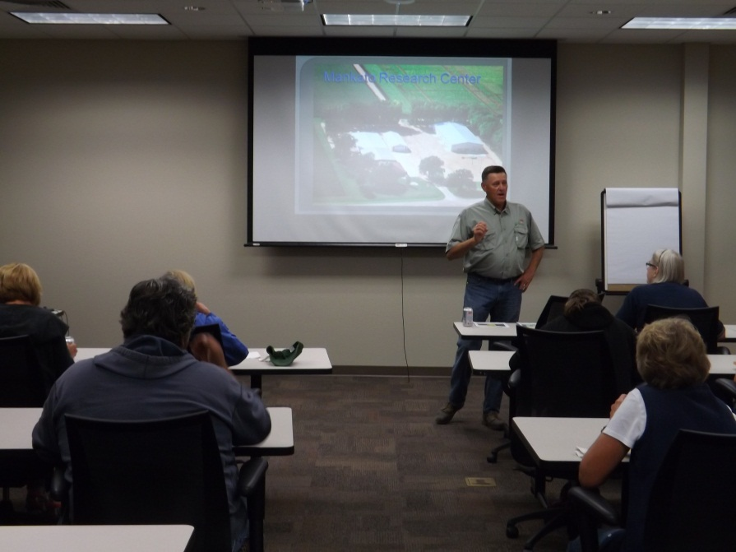
Teachers got the opportunity for some hands-on learning by pollinating corn plants at the DuPont Pioneer Research Center.
Crop producer Dan Ireland shared his experiences as a corn and soybean producer and Pioneer seed dealer.
Research Scientist Paul Gaspar demonstrates how to score roots on corn plants to measure the effectiveness of a genetic trait resistant to corn root worm.
Crop producer Dan Ireland shared his experiences as a corn and soybean producer and Pioneer seed dealer.
Research Scientist Paul Gaspar demonstrates how to score roots on corn plants to measure the effectiveness of a genetic trait resistant to corn root worm.

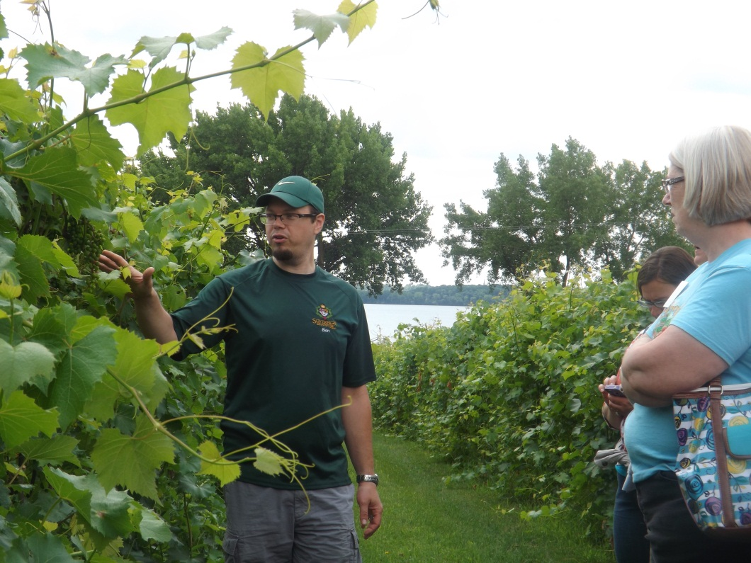
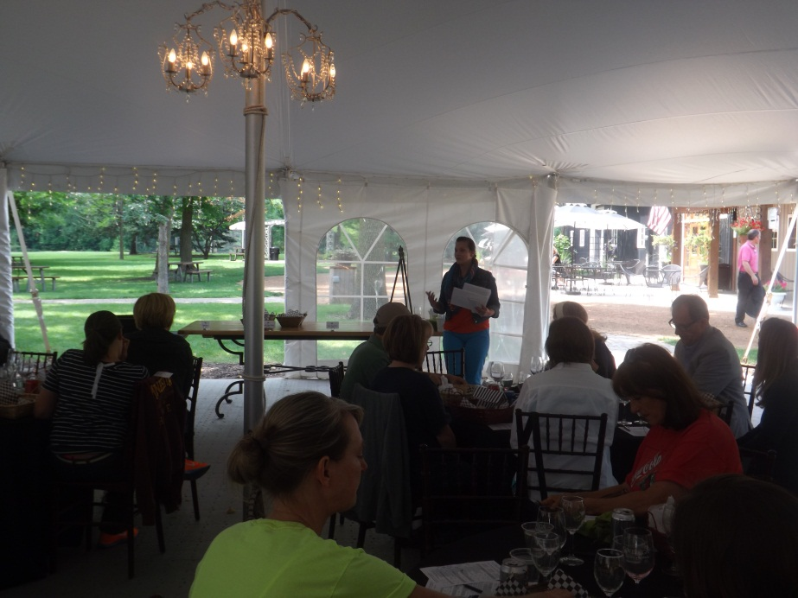
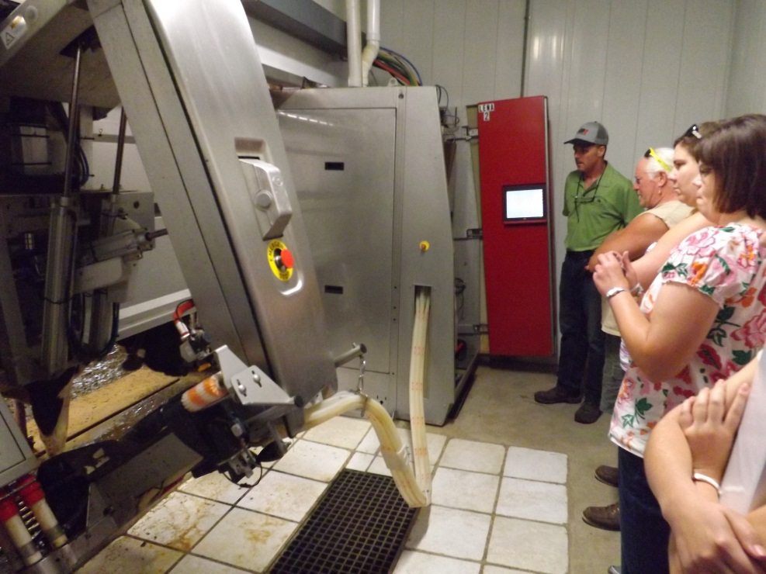
Cara Soper shares information about the food, fuel, and fiber uses of corn on behalf of the Minnesota Corn Growers Association.
Ben Savaryn explains the intensive process of growing grapes at Sovereign Estate Winery.
Dairy producer Paul Swenson explains how robots are used to milk cows on his fifth-generation farm.

The teachers who participated in the MAITC Summer Teacher Tour were asked to complete a pre-tour and post-tour evaluation. Their responses to the statement “I have skills that allow me to use agricultural content as an educational tool” are evidence that this tour positively impacted the teachers’ ability to utilize agriculture in their curricula and classroom.

Participants also offered the following remarks:
- “Besides being plain “fun” the tour and materials provided extensive resource materials to use as a follow-up”!
- “I thought the entire tour worked well under the main idea of farm to table. Each site was an example of each step in the process – examples that can be taken back to the classroom. Thank you for the great resources!”
- “The tours were very beneficial. I can now understand different parts of agriculture and share this with students.”

