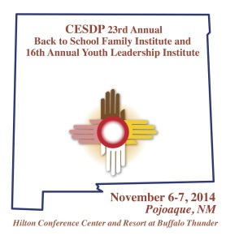
Register Now!
Registration Form
CESDP 23rd Annual Back to School Family and Youth Leadership Institute
Santa Fe Hilton at Buffalo Thunder · Pojoaque, New Mexico
November 6-7, 2014

Calculate total registration cost and submit payment or copy of purchase order with this registration and mail, fax, or email to:

Frances Mares-Morales
CESDP Back to School Institute
P.O. Box 9000
Las Vegas, NM 87701

Fax: (505) 454-3110 email: famares@nmhu.edu phone: 505-454-3367

20 Buffalo Thunder Trail
Santa Fe, NM 87506
www.santafebuffalothunder.hilton.com

Registrant Name(s):

Please do not make arrangements through the hotel. It may subject you to additional costs.
Use additional pages as needed

School District/Organization:

Address:

City:

State: Zip: Phone:

E-mail:

Include number of registrants:
1. ______ $200-1 Registration Only (Does Not Include Lodging)

2a.______ $300-1 Registration & 1 night lodging Nov. 5 or 6 for 1 adult __________indicate night

2b.______ $400-1 Registration & 2 nights lodging Wed. and Thurs., Nov. 5 & 6 for 1 adult

2c.______ $500-2 Registrations & 1 night lodging Thurs., Nov. 6 for 2 adults or students (One Room/Two Beds)

2d.______$600-2 Registrations & 2 nights lodging Wed. and Thurs. Nov. 5 & 6 for 2 adults or students (One Room/Two Beds)

2e.______$700-3 Registrations & 1 night lodging Thurs., Nov. 6 for 3 adults or students (One Room/Two Beds)

For additional options contact Frances at 505-454-3367 or famares@nmhu.edu

Subtotal: _______________

3. Childcare
$30.00 per day per child $60.00 for 2 days per child
Note:
We cannot register anyone without a check or purchase order.

We must invoice for the full amount of the purchase order despite any cancellations.

Subtotal: _________________

4. Exhibit Table Option _________$100.00 with Registration

Total Due: $

Type of Payment: ○ PO#

○ Check# _______________________

www.cesdp.nmhu.edu

