MPO to host 3rd Round of Public Meetings on Mobility 2040
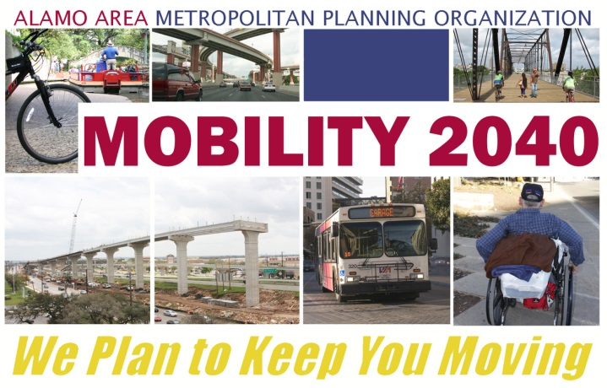
Mobility 2040 - Our Regional 25 year long-range multi-modal transportation plan
The Alamo Area MPO will be hosting the 3rd and final round of public meetings in support of the development of our region's long-range multi-modal transportation plan from October 1 through October 15, 2014.
Please join us for one of the meetings listed below.
All meetings will be similar in format and content. In addition to attending public meetings, your comments are welcome at any time through letters, e-mail, Facebook, phone calls or personal visits to the Alamo Area MPO offices.

All meetings will be held from 6 PM to 8 PM.
Seguin and Guadalupe County, Monday, October 13, 2014
Seguin-Guadalupe County Coliseum - 950 S. Austin Street
Seguin, TX 78155
Northwest San Antonio, Wednesday, October 15, 2014
Leon Valley Community Center - 6421 Evers Road
Leon Valley, TX 78238

Information presented at these meetings will also be available on our Mobility 2040 website at www.Mobility2040.org.
Back to top

