The mission state of the Warm Springs Watershed Association (WSWA) is “to protect and restore Warm Springs Run and its watershed through action based on education and the establishment of partnerships with concerned citizens, civic organizations, and governmental agencies of Morgan County and the state of West Virginia.”

If WSWA is known for anything, it is the partnerships it has established with other organizations in a collaborative effort to protect and restore the Run.

The EPCD, Morgan County School Board , local artist Mary Klotz, and WSWA are about to complete a project to install five educational kiosks into a wetlands area reestablished by the EPCD in 2009. The wetlands are located just south of Widmyer Elementary School.

EPCD and WSWA are also currently working with Morgan County businesses interested in becoming better stewards of the Run. WSWA members, Heather (Ishman) Duncan and Suzy Lucas will create a list of best management practices that could be adopted by businesses along WSR and in the watershed. Businesses can inventory current practices and then choose BMPs that will help to protect and restore Warm Springs Run. Upon successful implementation of these practices, WSWA will provide businesses with plaques they can display. The names of these businesses will also be listed on the WSWA website and Face Book page.

WSWA is also partnered with Cacapon Institute and the Town of Bath Tree Board to strategically increase the tree canopy of the watershed. In the past WSWA has planted trees to restore the riparian buffer of the Run. As important as that goal is, in planning for future projects we will also take into consideration how the placement of trees can help to reduce the volume and velocity of stormwater flowing into the Run. Our goal is to reduce erosion and thus the amount of sediment in the Run. Less sediment will create a better environment for macroinvertebrates living in the Run as well as to reduce the severity of flooding downstream.

In 2014 WSWA and the Town of Bath Cemetery Maintenance and Management Corporation (ToBCMMC) received a $50,000 grant from the National Fish and Wildlife Foundation to reduce erosion on the steep, denuded hills of Greenway Cemetery. WSWA has applied for a 2015 Stream Partners grant to install three demonstration projects designed to reduce stormwater runoff in the cemetery.

These best management practices include four projects. We will install conveyor belt diversions at strategic locations on gravel roads in the cemetery. This practice reduces erosion caused by flowing water that is trapped in wheel tracks and ruts by diverting concentrated drainage from the surface of the road while still allowing vehicles to pass. We will also install grassswales to promote the conveyance of stormwater at a slower, controlled rate; the grasses also act as a filter to remove pollutants and allow stormwater infiltration. We will improve sheet flow of stormwater by removing the berms accidentally created by maintenance practices and erosion from roads. These berms eventually function as a ditch that transports stormwater at a high volume and velocity. Finally, we will replace areas of turf grass with plants that slow and filter stormwater runoff. These plants also require less mowing than turf.

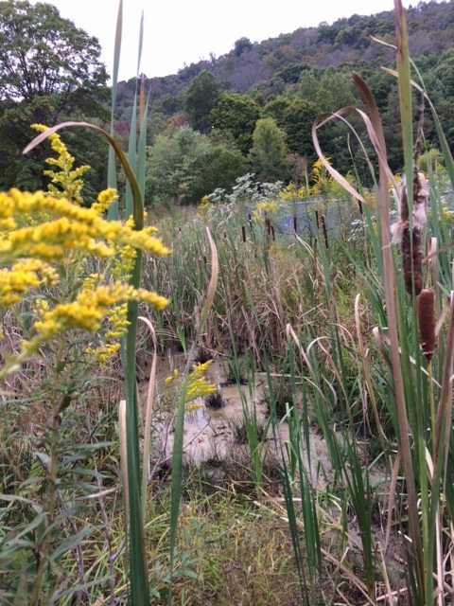 The Wetlands at Widmyer School in Berkeley County, WV.

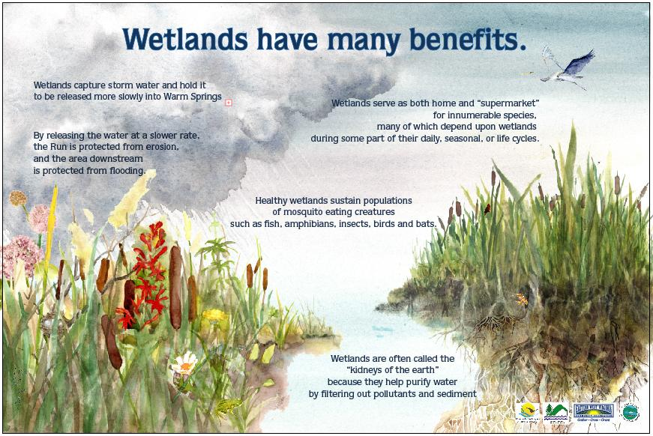 One of the seven kiosk signs for the wetlands installed at the Widmyer School in Berkeley County, West Virginia by the Warm Springs Watershed Association.