Eastern Panhandle Hosts Agricultural Field Day for Local Producers

If you were out for a drive on Winchester Grade Road in Berkeley Springs, WV on the afternoon of Saturday, September 13th you may have noticed signs pointing towards the “Eastern Panhandle Agricultural Field Day”, people standing in a corn field passing around clumps of soil, or you may have found yourself driving behind hay wagons full of people (62 people to be exact!) on their way to learn about ways to enhance their farming operations.
The Agricultural Field Day was an educational program that featured four stations: “Soil Testing and Nutrient Management”, “Pasture Management”, “Cover Crops and Soil Health”, and “Cost Share Programs, Riparian Buffers & Stream Health”. Participants learned valuable lessons at each station such as how to utilize nutrient management on the farm, establishing a rotational grazing system and measuring pasture productivity, the use of cover crops to improve soil health and nitrogen management, assessing stream health, and installing riparian buffers through the USDA CREP program.
While all of the above are equally important to agricultural productivity and sustainability, the highlight of the day was guest speaker, Troy Bishopp, AKA “The Grass Whisperer”, who came all the way from Deansboro, NY to “whisper” in the paddocks of Berkeley Springs about pasture management. “The Grass Whisperer” showed everyone what a “cow-day” looks like (in other words, the area of pasture that 1 cow will graze down in 1 day), looked at pasture composition and density, and discussed methods of rotational grazing that establish more uniform grazing patterns and ultimately increase pasture productivity. Troy explained that the key to making quality pasture is giving you grass plenty of “fertility and rest, rest and fertility!” The “fertility” being the manure that, through a properly established rotational system, would be evenly spread over each paddock. The “rest” being the time that the paddock goes un-grazed while the cattle are rotated through other paddocks, allowing the grass to re-establish itself into a dense and healthy stand.
The Eastern Panhandle Agricultural Field Day was graciously hosted by farmer and Eastern Panhandle Conservation District Supervisor Jim Michael and his family. The Michael’s farm was an ideal location for this field day, in part because it is located in the Sleepy Creek watershed. Sleepy Creek is impaired for fecal coliform bacteria and there is currently an effort in place to reduce the levels of bacteria in the stream. This field day played a large role in that effort by encouraging agricultural management practices in the Sleepy Creek Watershed that will help reduce bacteria levels in the stream.
This event would not have been possible without the dedicated team of natural resource providers that spoke at each station: Jason Dalrymple, WVDA; Tim Canfield, USDA-NRCS; Brad Michael, Producer; Michael Harman, WVU Extension; Norm Dean, SCWA; Herb Peddicord, WV DOF; and Robyn Potter, USDA-FSA. The event was sponsored by the Eastern Panhandle Conservation District, WV Conservation Agency, T.A. Seed, Dawson’s Home Center, Southern States, Tractor Supply, Kitchen’s Orchard and Farm Market, Butler’s Farm Market,Mid-Atlantic Farm Credit, Taylor’s Farm Market and Tony Petrucci.

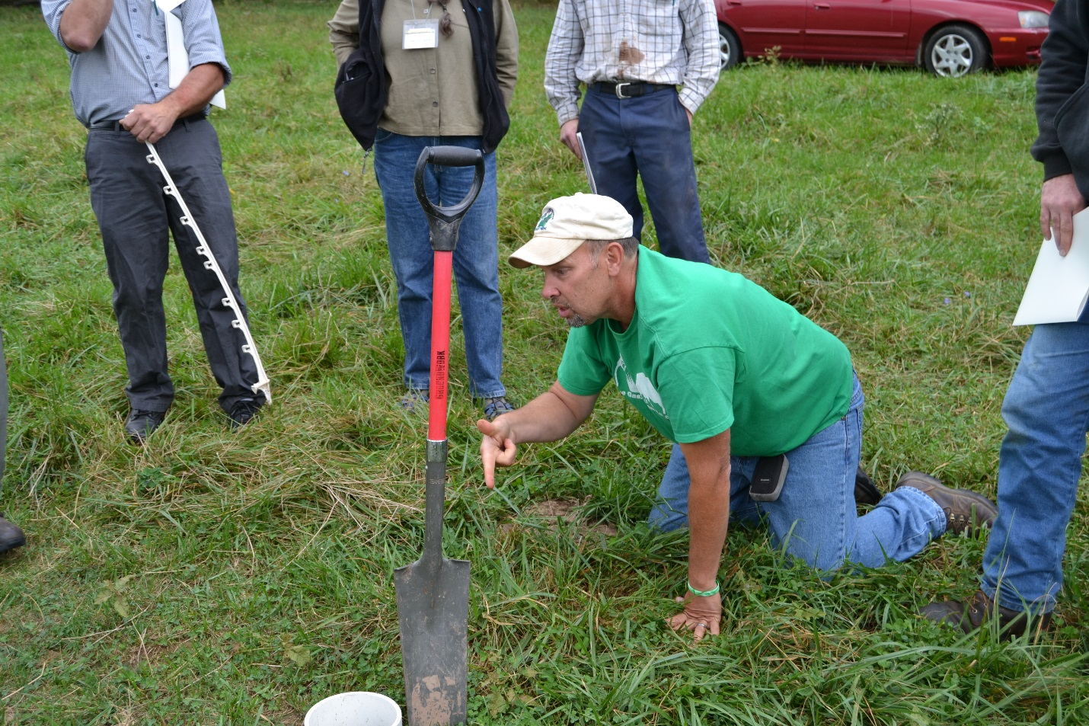
Figure 1. "The Grass Whisperer" shows participants how to assess pasture productivity.
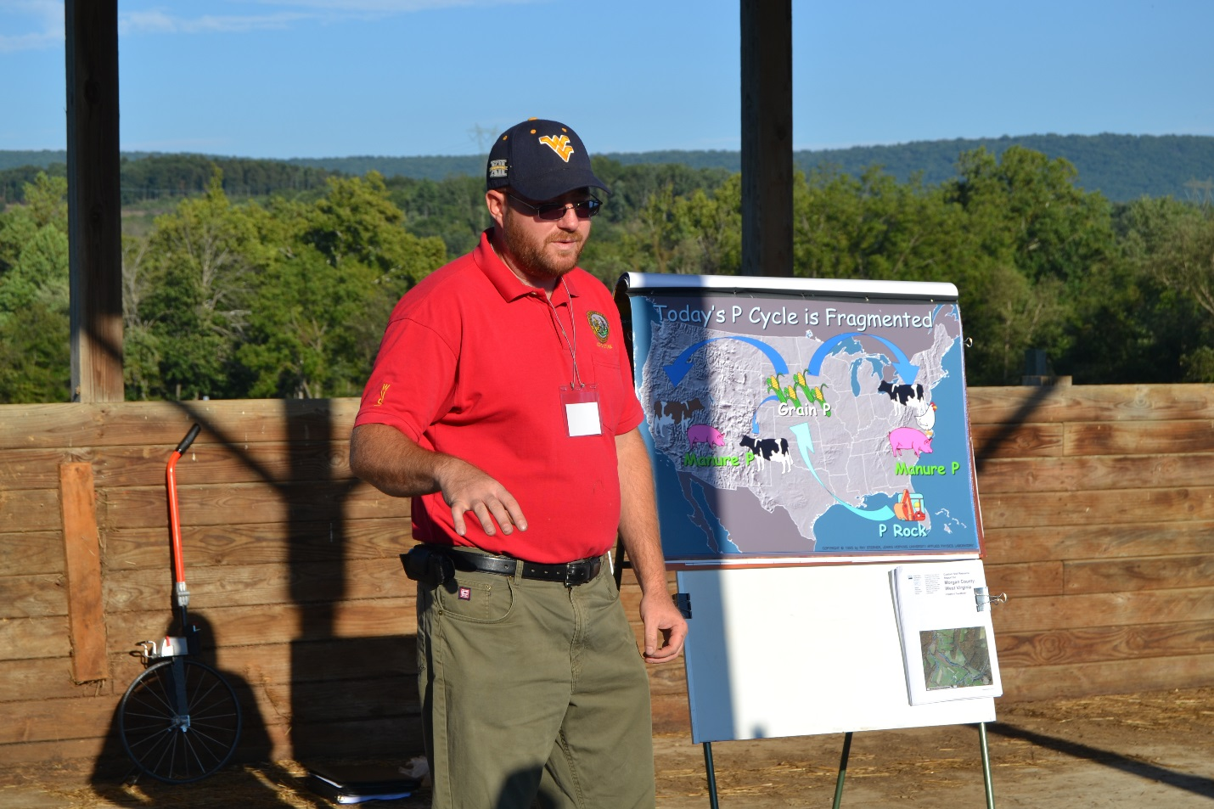
Figure 2. Jason Dalrymple of WVDA discusses the importance of Nutrient Management
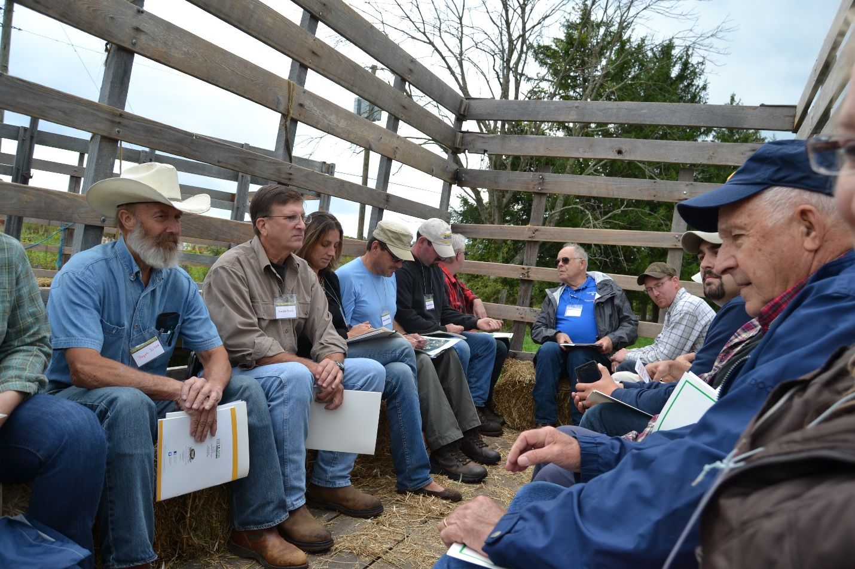
Figure 3. Participants take a hay ride between stations.

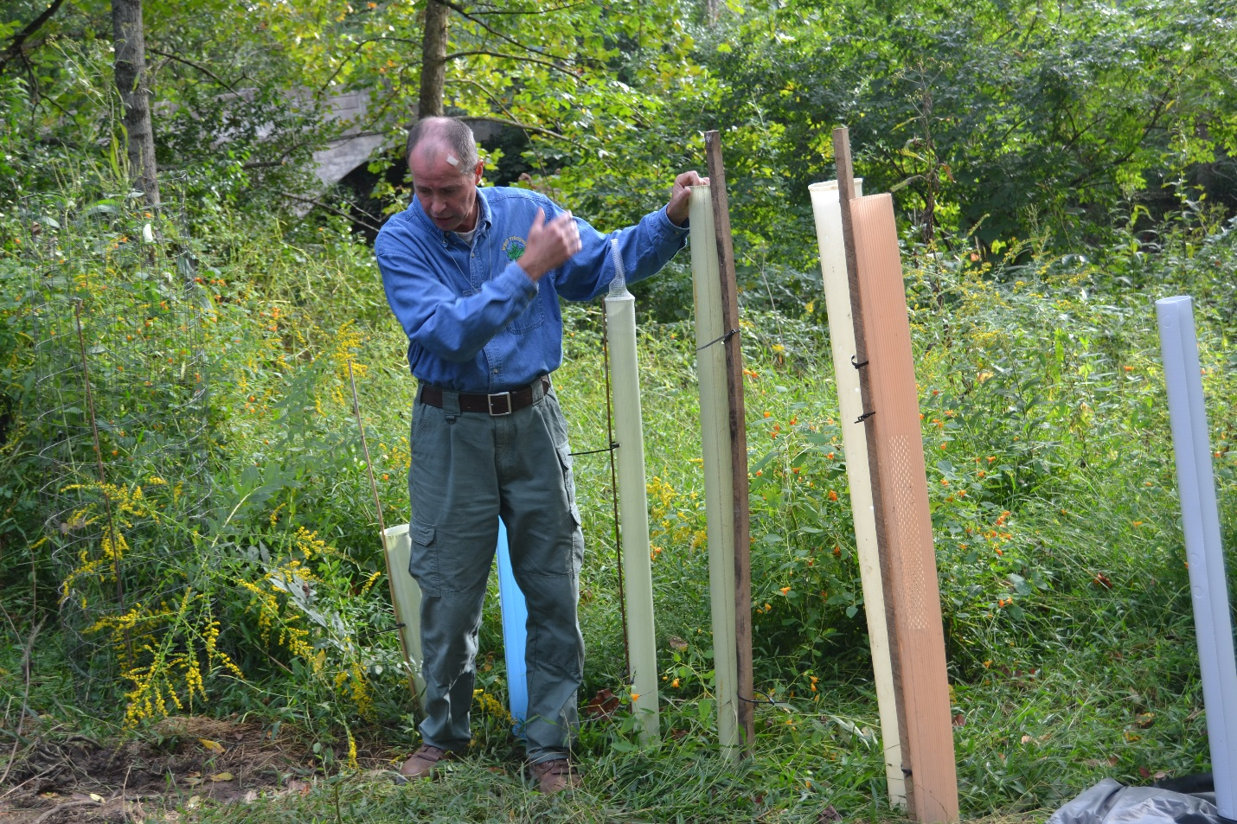
Figure 4. Chesapeake Bay Forester, Herb Peddicord, discusses methods of protecting your freshly planted trees from deer browsing.
Figure 5. Jim Michael, producer and land owner, proudly describes his cattle herd to his wagon passengers.

Figure 6. Michael Harman of WVU Extension describes the establishment of a healthy soil structure through the use of no-till drilling and cover cropping.

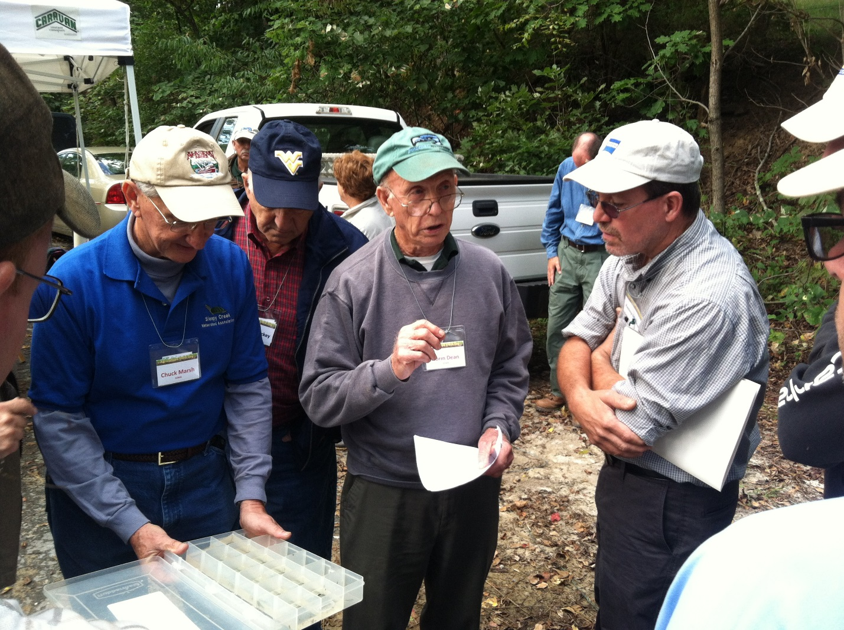
Figure 7. Norm Dean and Chuck Marsh of Sleepy Creek Watershed Association explain how the presence of certain aquatic organisms in the stream relates to water quality.

