On October 26, 2013 a very large riparian buffer was established by 26 hardworking volunteers in Morgan County, WV on a tributary of Sleepy Creek. The buffer, consisting of 393 trees, was installed on the Hess Farm, owned by siblings Kelly Hess, Robert Hess, Casey Hess, and Lynn Gomez. Combining both sides, the planting is 35 ft. wide by 1,980 ft. long and 1.6 acres in area. All 393 trees were planted, tubed (or caged), and staked in a matter of 5 hours. Owner Kelly Hess said “This is the first time I’ve ever been a part of something where everyone came together like this and worked so diligently. The planting was in great order and went really well.”
This planting was funded by federal Watershed Project Grant from EPA’s Clean Water Act Section 319, the aim of which is to achieve Sleepy Creek’s TMDL for fecal coliform bacteria. One mission of the grant is to establish 4 acres of riparian buffer. This planting alone has accomplished 40% of that goal and will reduce bacteria counts in the stream by 1.05E+12 colony forming units/100 ml. The buffer will prevent bacteria from entering the stream by controlling agricultural runoff from pasture fields. Farmer Kelly Hess told the group “My kids play in this stream, I want to do what I can to keep it clean for them!”
The Hess riparian planting could not have been possible without the hard work of the partners who worked to implement key components of the Sleepy Creek Watershed Project Grant throughout this project. These partners are West Virginia Division of Forestry, Sleepy Creek Watershed Association, West Virginia Conservation Agency, Eastern Panhandle Conservation District, and West Virginia Department of Environmental Protection.

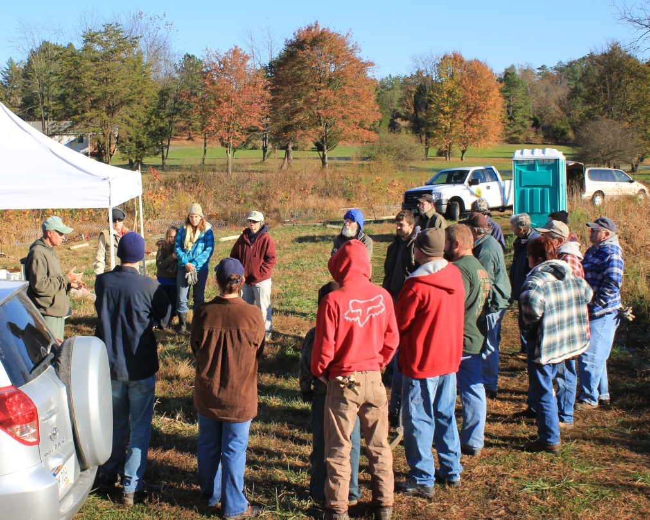
WVDOF Chesapeake Bay Forester, Herb Peddicord gives a planting demonstration to volunteers.
WVDEP Potomac Basin Coordinator, Alana Hartman planting a Walnut tree.

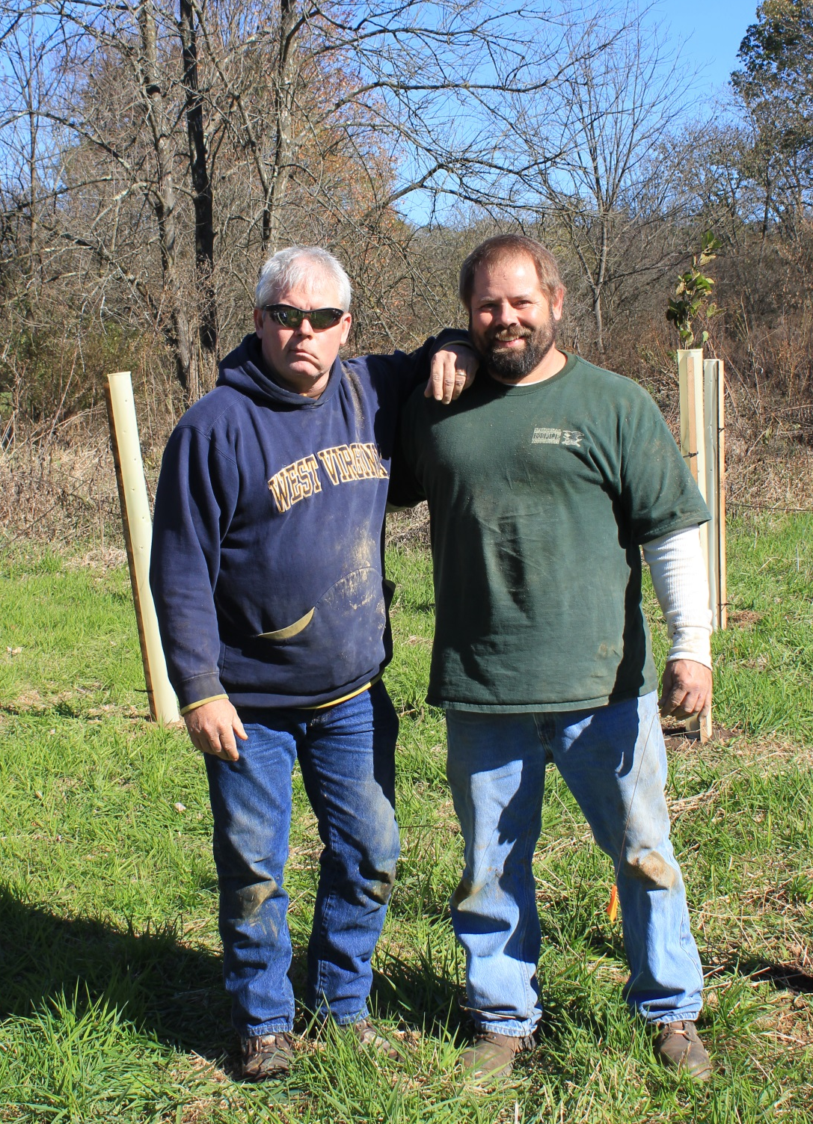
Brothers and Farm Owners Robert Hess and Kelly Hess after a hard days planting!
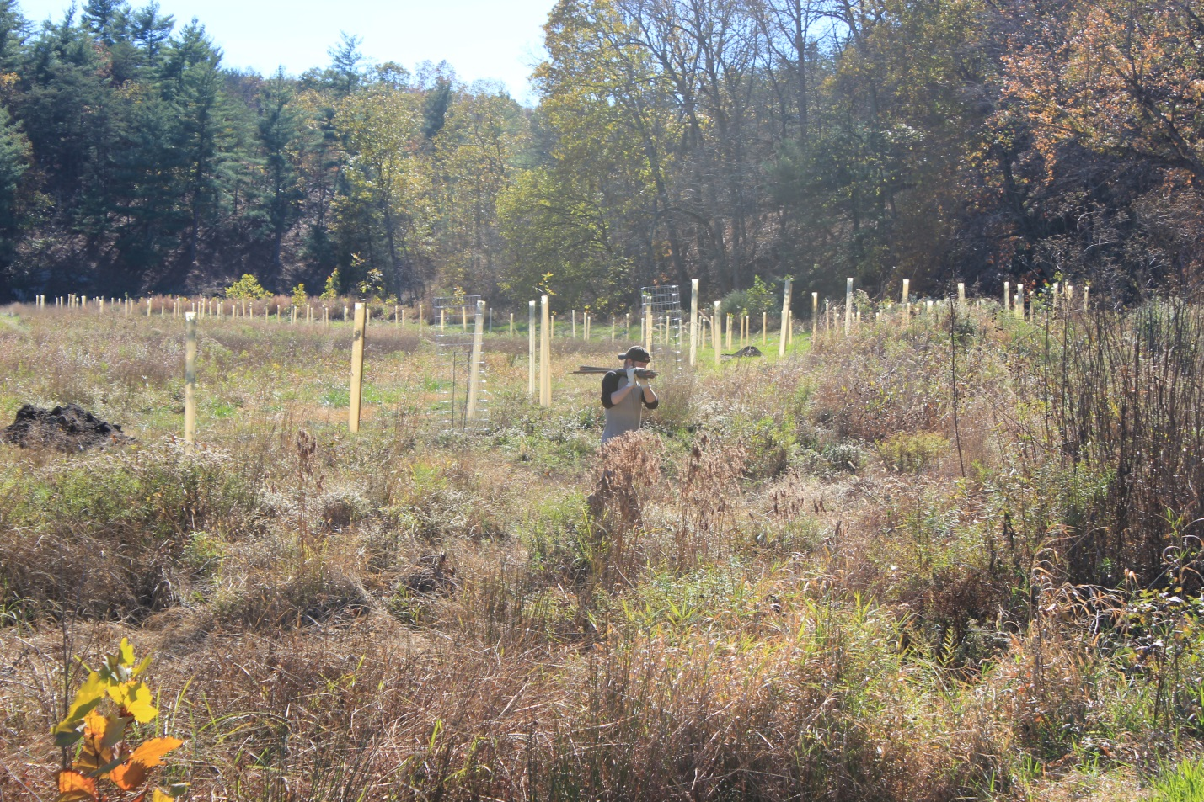
Trees as far as the eye can see!

