Petersburg Drain Sign Initiative
By Melissa Merritt, WVCA
In many states, cities are taking the initiative to label stormwater drains with signs to bring awareness of how everyone can prevent water pollution. As of this past spring, the City of Petersburg chose to follow suit with its own water awareness project. The 5th grade class of Petersburg Elementary school recently took part in a contest to design the best drain label to protect the South Branch River from pollution. In the spring of 2014, students were asked to draw any picture that would convey the reason why people shouldn’t “dump” or pollute near the drains of Petersburg, WV. The purpose of the project is to remind residents that anything dumped onto streets and lawns can be washed into the drains when it rains, which lead straight into the South Branch River, which eventually leads to the Chesapeake Bay.
The first place winner of the competition was Isaac Snyder, second place was Isaac Nazelrodt, and third place was Jenna Burgess. The installation of these drain signs will take place in the fall of 2014. There are 61 drains in Petersburg, West Virginia, and by this upcoming school year, every one of them will be marked with the artwork from these students reminding folks to be mindful to keep our rivers clean!
This project was also showcased in the U.S. Department of Education’s Green Ribbon Schools Healthy Schools, High-Achieving Students Best Practices Tour 2014, to celebrate Petersburg Elementary School’s recent acceptance as a Green Ribbon School in this national program. The Green Ribbon School initiative highlights schools’ reduction of environmental impact and costs, improvement of health and wellness, and a focus on environmental education.
Pictures below.
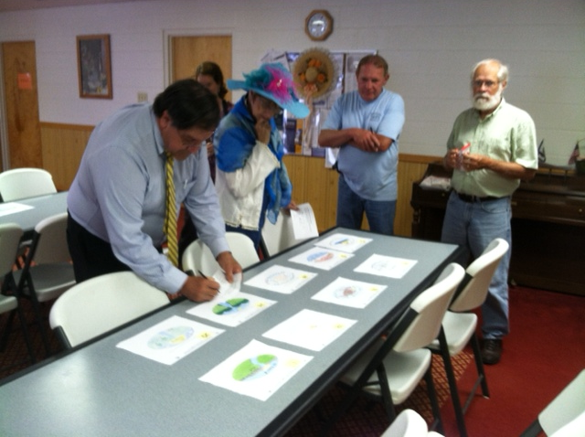 The judges of the Petersburg Drain Sign Contest from left: Gerald Sites, Grant County District Supervisor from the Potomac Valley Conservation District, Donnalie Hope with the City of Petersburg, Louis Alt from Petersburg Parks and Recreation, and Tom Hencke, Editor of the Grant County Press.

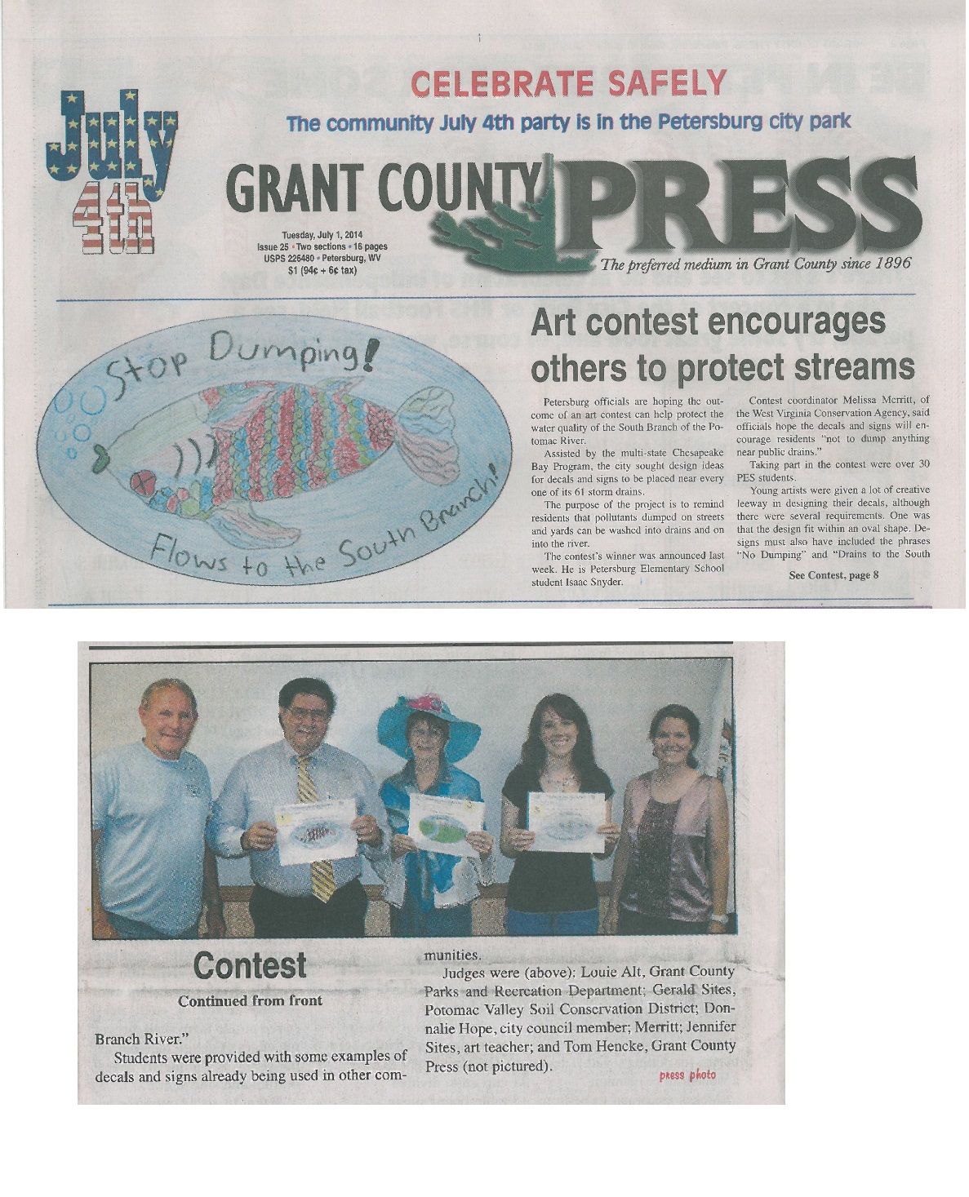Original article as it appeared in the Grant County Press on July 1, 2014.

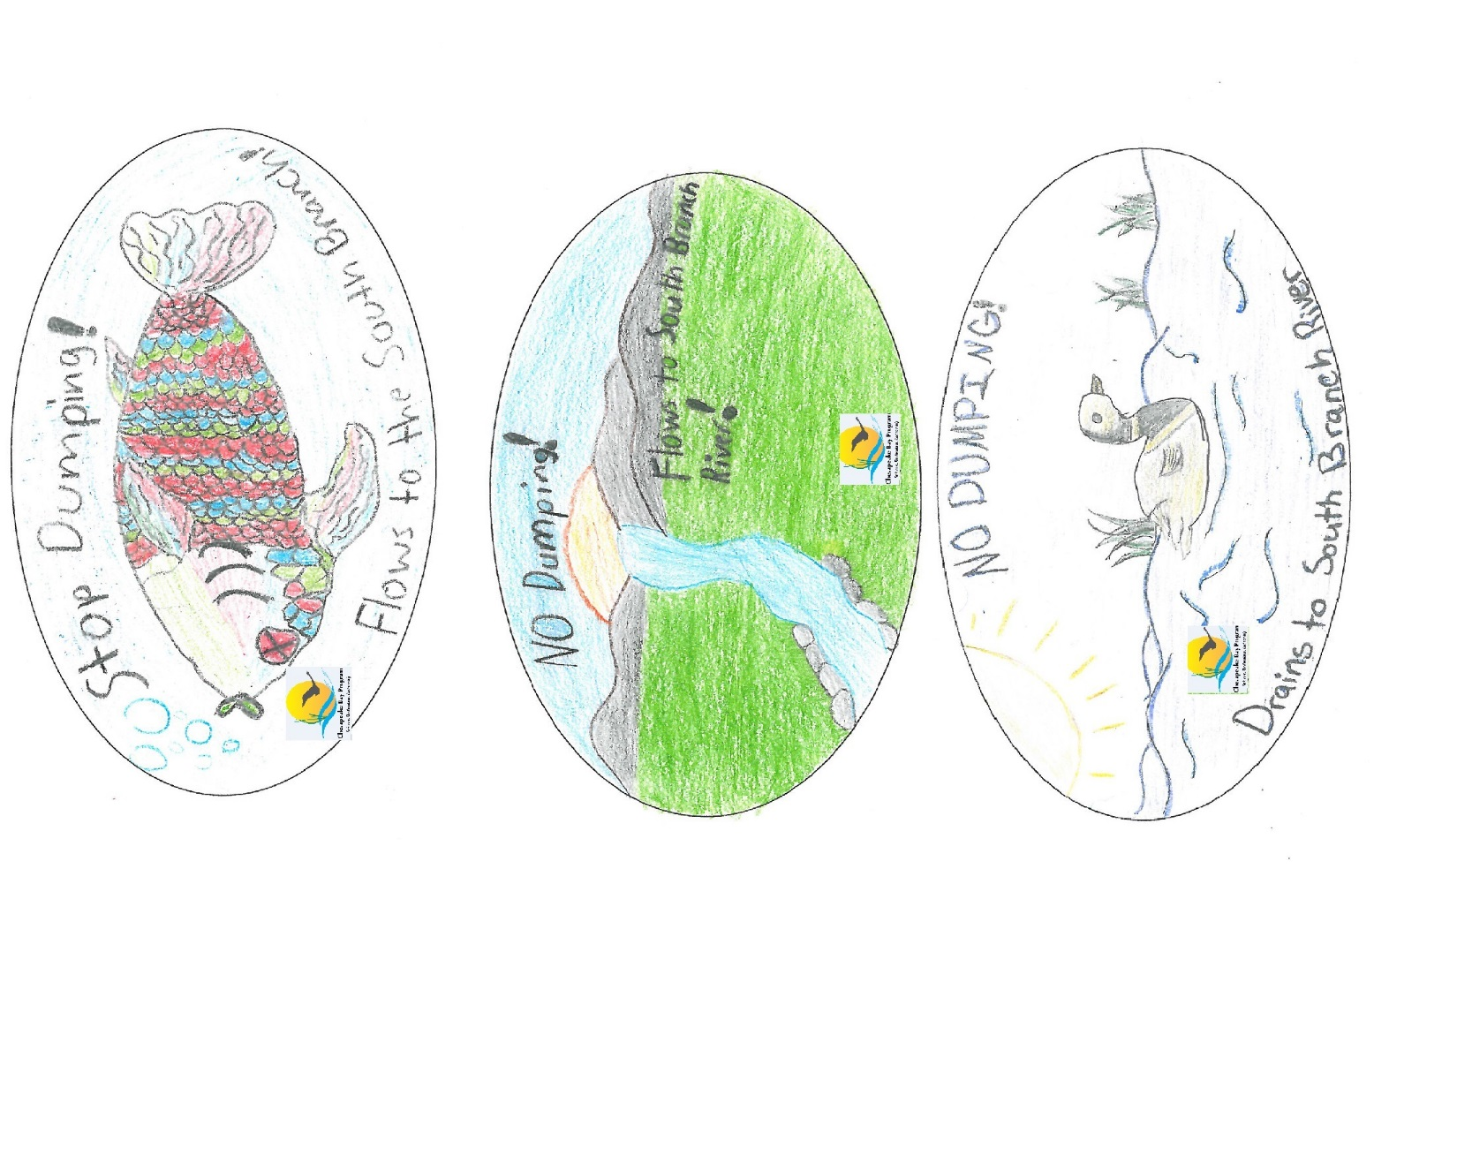 From top: The first place winner of the competition was Isaac Snyder, second place was Isaac Nazelrodt, and third place was Jenna Burgess

