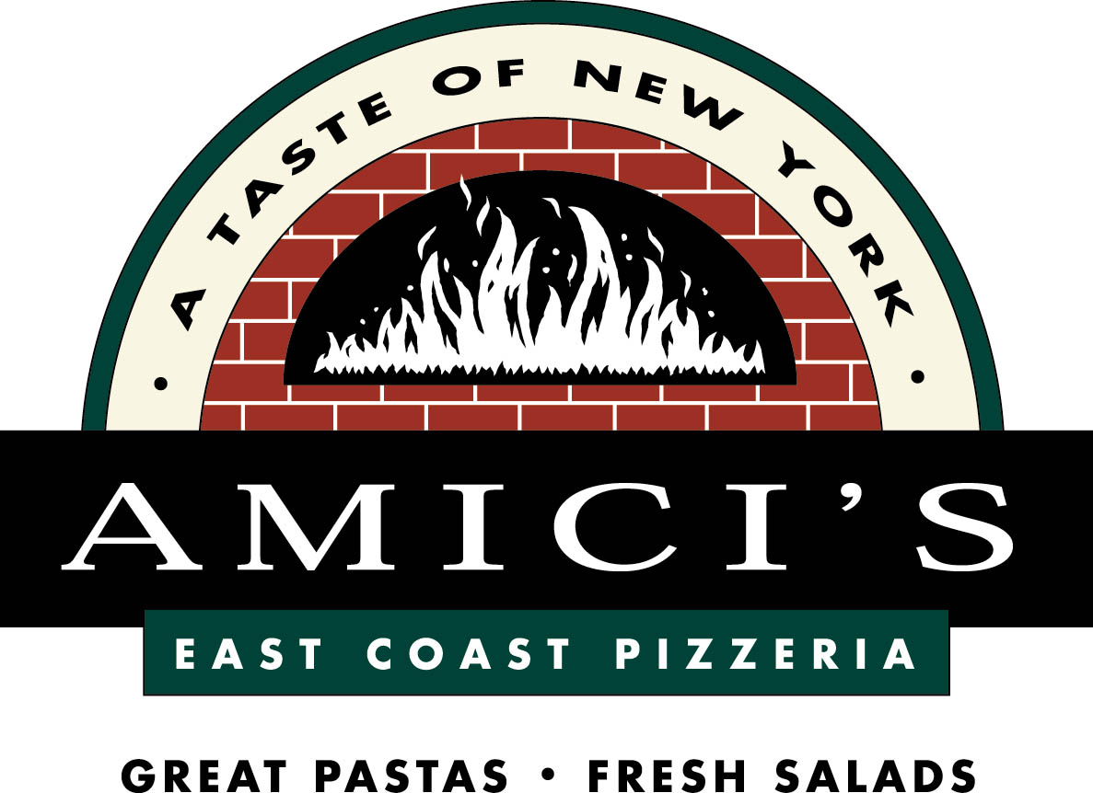

Ormondale and Corte Madera School Families
Bring your family & friends and join us in a
Pizza and Pasta Fundraiser
for the PVSD-PTO

Amici’s East Coast Pizzeria
880 Santa Cruz Avenue
Menlo Park
650-329-8888

On Tuesday, March 18th
5pm to 9pm
Dine In or Take Out
(no deliveries) l

Present this flyer and Amici’s will generously donate 25% of your
food and beverage purchases to help support
Ormondale and Corte Madera PTO’s

This fundraiser event is valid only at the Amici’s
location in Menlo Park. Amici’s cannot promise seating
together for large groups. Gift Certificates available too.
Thank you Amici’s

