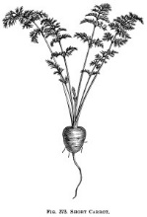
Thanksgiving
Prix fixe menu
$50.00 per person

Nibbles to share
First Course
Butternut Squash or Seafood Chowder

Second Course
Mesclun salad with balsamic dressing & shaved carrot

Third Course
Choice of:
Roasted turkey With traditional sides
Or
Baked salmon With traditional sides
Or
Prime rib With traditional sides

Fourth Course
Choice of:
Pecan pie
Or
Pumpkin pie with marshmallows
Or
Apple pie

