HR North Steering Committee Members

Claire Dunleavy, leading our efforts
Charles Greenhalgh Jennifer Moeckel - Programs
Mary Gueymard Bryan Morin
Beth Hutchins - Social Media Greg Nolin-Membership
Josh Robinson-Membership Scott Smith-Treasurer
Tammy Johnson-Website Sabrina Wood-Rennie-Membership
Tina Lunderville – Membership

2014- 2015
Program of Events

Benefits of Membership

- North of the Notch Networking with peers, experienced
HR Professionals, Business Owners, and Legal Partners
- Education and Seminars - closer to you
- Discounted rate for HR North Events
HR North Mission Statement:

HR North aspires to be a strong and diverse chapter, reflective of the unique North Country character and challenges. We are dedicated to strengthening our businesses, organizations, and the community, and to fostering professional growth.

HR North is a newly established satellite of the Society for Human Resource Management (SHRM) Human Resource Association of Greater Concord (HRA-GC) Chapter consisting of Human Resource professionals, community and business leaders who are dedicated to bringing resources, education, and networking to the North Country.

- Discounted rate for all NH SHRM Chapter Events
- Access to “Members Only” sections to
HRA-GC/ HR North website and membership lists
- Join at: www.HRA-GC.org before July 1, 2014 – $50
after July 1, 2014 - $60

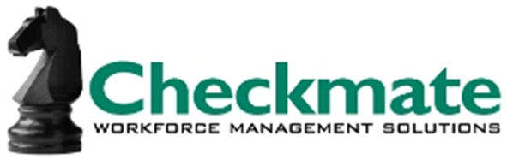
2014 - 2015 Sustaining Sponsors
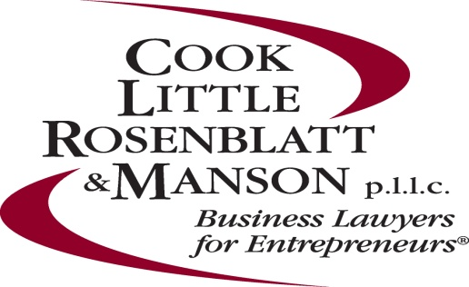
One Sponsor slot available:
Your company LOGO could be here

Calendar of Events

All Events are $20 for members and $40 for non-members
To register for events please visit: www.hra-gc.org
Each event has been submitted for 1.5 HRCI Credits

Scott’s presentation will focus on providing you with the tools for understanding your employee demographics, their needs and interests, the impact age has on workers‘comp claims, the overall HR strategy and how it aligns with your business strategy.

Giving feedback to employees and colleagues is a crucial and sometimes difficult task. This session will include helpful suggestions, question some commonly accepted tactics, and encourage participants to incorporate creative approaches into their natural communication styles.

December 4, 2014, 4:30 pm – 7:00 pm
Title: Social Media Minute - A Networking Social Event
Presenter(s): Beth Hutchins
Location: Cranmore Mountain
Best practices for social media use personally and professionally. This quick presentation will include a brief overview of social media including Facebook, Twitter and LinkedIn as well as tips for maintaining privacy and professionalism in individual and business interactions.
For membership or registration info, visit: www.HRA-GC.org

For questions regarding HR North, please contact
Claire Dunleavy at hrnorthnh@gmail.com
Visit our page at www.facebook.com/pages/HR-North/306158979484281

Join us on Linkedin

January 14, 2015, 8:30 am – 11:30 am
Title: Compensation – More Than Just Money
Presenter(s): Bill Irvine
Location: Woodstock Inn, No. Woodstock, NH
This presentation will explore the Compensation Strategy of an organization and the value of Aligning the Business Culture to that strategy. We will look at Organizational Philosophies and its impact on designing various Compensation Programs and consider other factors besides money that motivate and provide purpose for people to perform and be productive. We will consider a few tactical processes when Developing Pay structures; and finally. Bill will provide some Guidelines and take-aways for participants to consider within their individual organizations

March 19, 2015, 8:30 am – 11:30 am
Title: Unemployment Law – from Soup to Nuts
Presenter(s): Dianne Carpenter, Erika Randmere, Colleen O’Neill, and an Employment Law Attorney
Location: Red Jacket Mountain View Resort, No. Conway, NH
This seminar will review the unemployment insurance claim process from how it is funded to how benefits are paid. It will include a review of unemployment law and compliance requirements. You will learn how to appeal a determination for unemployment benefits as well as what takes place at the appeal hearing. Employment law, policy development and enforcement, as well as employment termination will also be discussed.

May 27, 2015, 8:30 am – 11:30 am
Title: Collaborative – Whole Person Leadership
Presenter(s): Michael Kline, Motivational Speaker
Location: Attitash Grand Summit Hotel, Bartlett, NH
Kline Seminars offers expertise in Art of Hosting practices; a suite of facilitation tools and a philosophy that draws out collective wisdom from groups. When people are invited to work together on what truly matters to them, they take ownership and responsibility for moving their issues and ideas into wiser actions that last. Attend this program to learn more about some of the facilitation practices and patterns that can bring collaboration and shared leadership at every level in your organization.

June 10, 2015, 8:30 am – 11:30 am
Title: Employment Law Update & Implementation Tips for 2015
Presenter(s): Jennifer Moeckel, Attorney
Charles Greenhalgh, Attorney
Location: Town & Country Inn, Shelburne, NH
This session will provide an overview and analysis of recent court and agency decisions and legislative changes. Presenters will also provide practical tips and take-aways for HR professionals, managers, and business owners to use in adapting their policies and procedures to recent changes in the legal landscape.

September 23, 2014, 8:30 am – 11:30 am
Title: The Effects of the Aging Workforce
Presenter(s): Scott Lawson
Location: The Inn at Whitefield, Whitefield, NH

November 19, 2014, 8:30 am – 11:30 am
Title: Evaluating & Monitoring Performance in a
Blame Free Environment
Presenter(s): Gerri King, Ph.D.
Location: Red Jacket Mountain View Resort,
No. Conway, NH

