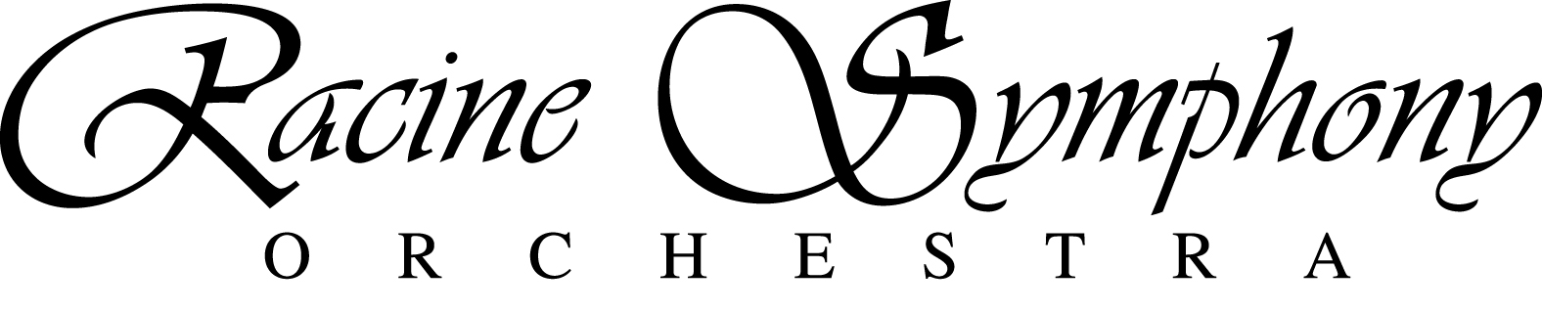

October 2013

Dear Racine Symphony Orchestra Patron

As 2013 winds down and the holidays rapidly approach, we at the Racine Symphony look back with excitement of progress to date and with our sights set even higher for the coming year and season. Happily, the 2012-13 season marks the fifth consecutive season of sound fiscal management – a balanced budget. You, our loyal patrons, have, and will no doubt continue to play, a significant role in sustaining that accomplishment. Your contributions and ticket purchases cover about one third of our operating expenses. We thank you for helping us reach this milestone and ask for your help in continuing our operations.

While building financial stability, the RSO still was able to sustain our current programming level, and even expand upon it, thanks to you! We, with your help, continue to support and inspire our youth by means of sponsoring the scholarship-awarding Young Artists’ Competition, organizing the Side-by-Side musician experience, and, of course performing the FREE concert for Fifth Graders. One student who attended the concert, Alyssabeth Alba-Garcia of Roosevelt Elementary, was so moved by her experience that she wrote to us, “…the best part of the concert was Mendelssohn’s Cave…I could see it in my mind, as soon as the tremendous waves burst in like a pack of wild animals, the orchestra got louder. Then as soon as the waves slowed down the orchestra got softer…..Thanks again for everything and thanks for giving up your free time to put together the amazing show.” Your donations helped make this experience possible!

Our artist in residence presents, and will continue to present, interactive recitals within the Racine community in places such as daycares and assisted living facilities, stimulating minds of all ages, again thanks to the generosity of you, our donors. Expanding our number of concerts compared to last season, the first concert of 2014 will mark the return of Sunday afternoon concerts-something you, our patrons requested. We were elated to perform for a sell-out crowd at the 2012 Holiday Pops and honored with your support for our annual special event at Wingspread.

We continue to explore ways to reach more patrons, future patrons and hopefully inspire future musicians. However, to continue to provide the current level and reach of quality cultural programming that you enjoy, let alone to expand our docket and community reach, we unequivocally rely on your generous support. Please, continue your support of the Racine Symphony Orchestra and its positive impact upon the Racine community with a donation. You can, and do, make a difference!

Thank you!

Cory Mason, III Bonnie Prochaska

President, Board of Directors Executive Director

Pasquale Laurino, Artistic Director

P.O. Box 1874, Racine, WI 53401  262.636.9285  [www.racinesymphony.org](http://www.racinesymphony.org)

# board of directors

# Officers

Cory Mason, III

*President*

Roberta Stark

*Vice President*

Dave Easley

*Secretary*

Stephen McLaughlin

*Treasurer*

# Members

Renee Andronczyk

David R. Beach

Sue Cawley

John Crimmings

Nicole D’Amour

Suzanne Geoffrey

Gretchen Herrmann

Steven Kaufman

Hilary Krejcha

Tammy Leverich

Nancy Maio

Tom Meredith, II

Susan Sanabria

Roberta Stark

# EXECUTIVE DIRECTOR

Bonnie Prochaska

# ARTISTIC DIRECTOR

Pasquale Laurino