Sign up Today!!!!

~ Pumpkins ~ Baked Goods ~

MC900183270[1]MC900183270[1] 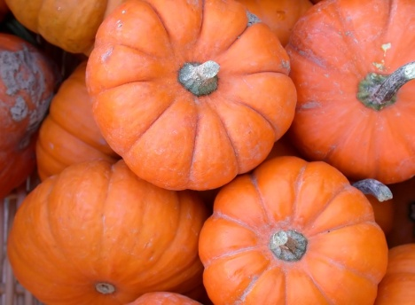

October 18th and 19th

We need volunteers for:

~ Baking

~ Unloading Pumpkins

~ Working the Pumpkin and Bake Sale

Sign up to Help:

Help bake: [www.SignUpGenius.com/go/60B0F4AAEA72FAB9-pumpkin1/20161949](http://www.SignUpGenius.com/go/60B0F4AAEA72FAB9-pumpkin1/20161949)

Work at the Sale: [www.SignUpGenius.com/go/60B0F4AAEA72FAB9-pumpkin/20161949](http://www.SignUpGenius.com/go/60B0F4AAEA72FAB9-pumpkin/20161949)

For questions or to volunteer, please contact:

Shauna at 740-815-9053 [shaunardurant@gmail.com](mailto:shaunardurant@gmail.com) or Mary at 513-432-9098 [mehagen1@gmail.com](mailto:mehagen1@gmail.com)