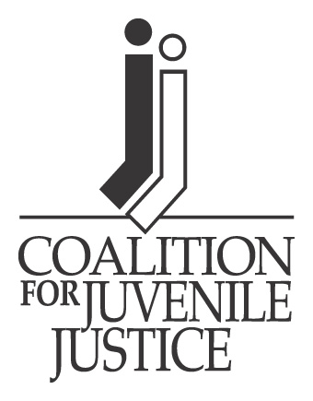
CJJ Annual Conference:
“Looking Back, Planning Ahead: A Vision of the Next 40 Years in Juvenile Justice”
June 18-21, 2014
Washington, D.C.

2014 Hill Day Advance Packet

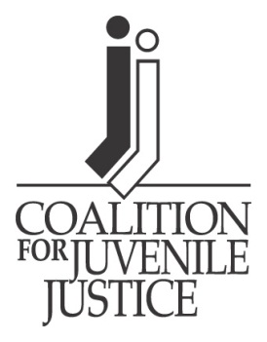
Dear CJJ Member and Ally:

The Coalition for Juvenile Justice (CJJ) 2014 Annual Conference, “Looking Back, Planning Ahead: A Vision for the Next 40 Years in Juvenile Justice” is fast approaching, and we are working hard to build what promises to be an informative and dynamic program.

As in past years, the CJJ Government Relations Committee is encouraging all conference attendees to take advantage of Hill Day, which will be held on Wednesday, June 18 this year to give you a chance to meet with your congressional delegations and share information about your state’s juvenile justice needs and accomplishments.

We also hope that you will join us for our Hill Day training—offered via webinar this year! There will be a live Hill Day Webinar May 15 and June 4. We will also have staff available to answer any additional questions on Hill Day.

For your convenience and information, we have developed this Hill Day Advance Packet which includes information about the 113th Congress, a map of the Capitol, and instructions for scheduling appointments with your state’s Congressional Representatives.

In an effort to strengthen member engagement in CJJ’s federal policy agenda, we have provided a Post-Hill Day Survey. Staff will also be available to answer questions during the conference. Collecting information about members’ hill visits is one of our top priorities, and your participation is appreciated to help us achieve this goal.

Should you have any questions or concerns, please don’t hesitate to contact us. Thank you and we look forward to seeing you very soon in Washington, DC!

Ken Schatz, Co-Chair, CJJ Government Relations Committee, Vermont SAG, 802-865-7121 or kschatz@state.vt.us

Cecely Reardon, Co-Chair, CJJ Government Relations Committee, Massachusetts, 617-960-3330 or creardon@publiccounsel.net

Naomi Smoot, Policy and Government Relations Associate, 202-467-0864 ext. 109 or smoot@juvjustice.org

Hill Day Advance Packet: What’s Inside?

An Overview of the 113th Congress……………………………..………...…Page 4

A Map of Capitol Hill……………………..………………………………......Page 7

Training and Debriefing…….…………...……...………………………….........................…Page 8

Meeting with Your U.S. Representatives:
What to do Before, During, and After the Visit……………..………….….Page 9

Top Ten Tips for Meeting with Your
Member of Congress………………………………………….……….........…Page 10

Post Hill Day Survey………………….………..…………………….….........Page 11

Sample Appointment Request Letters………..……………………….........Page 13

Leadership in the 113th Congress

Senate Majority Leader House Speaker
Harry Reid (D-NV) John Boehner (R-OH-8)

Senate Minority Leader House Minority Leader
Mitch McConnell (R-KY) Nancy Pelosi (D-CA-8)

Senate Composition House Composition
53 Democrats 199 Democrats
45 Republicans 232 Republicans
2 Independents 4 Vacant (as of 3/11/14)

Key Senate Committees
SENATE APPROPRIATIONS COMMITTEE
Chair – Barbara Mikulski (D-MD)
Ranking Member – Thad Cochran (R-MS)

Senate Appropriations Subcommittee on Commerce-Justice-Science (CJS)
Appropriating committee for all federal juvenile justice programs
Chair - Barbara Mikulski (D-MD)
Ranking Member – Richard Shelby (R-AL)

Democratic Members: Republican Members:
Patrick Leahy (VT) Mitch McConnell (KY)
Dianne Feinstein (CA) Lamar Alexander (TN)
Jack Reed (RI) Susan Collins (ME)
Chris Coons (DE) Lisa Murkowski (AK)
Mary Landrieu (LA) Lindsey Graham (SC)
Mark Pryor (AR) Mark Kirk (IL)
Jeanne Shaheen (NH) John Boozman (AR)
Jeff Merkley (OR)

SENATE JUDICIARY COMMITTEE
Authorizing committee for JJDPA, JABG, and Youth PROMISE Act
Chair – Patrick Leahy (D-VT)
Ranking Member – Chuck Grassley (R-IA)

Democratic Members: Republican Members:
Dianne Feinstein (CA) Orrin Hatch (UT)
Chuck Schumer (NY) Jeff Sessions (AL)
Dick Durbin (IL) Lindsey Graham (DC)
Sheldon Whitehouse (RI) John Cornyn (TX)
Amy Klobuchar (MN) Michael Lee (UT)
Al Franken (MN) Ted Cruz (TX)
Christopher Coons (DE) Jeff Flake (AZ)

Richard Blumenthal (CT)

Mazie Hirono (HI)

Key House Committees
HOUSE APPROPRIATIONS COMMITTEE
Chair – Harold “Hal” Rogers (R-KY-5th)
Ranking Member – Nita Lowey (D-NY-17th)

House Appropriations Subcommittee on Commerce-Justice-Science (CJS)
Appropriating committee for all federal juvenile justice programs
Chair – Frank Wolf (R-VA-10th)
Ranking Member – Chaka Fattah (D-PA-2nd)

Republican Members: Democratic Members:
John Culberson (TX-7th) Adam Schiff (CA-28th)
Robert. B Aderholt (AL-4th) Michael “Mike” Honda (CA-15th)
John Carter (TX-31st) Jose Enrique Serrano (NY-16th)
Mario Diaz-Balart (FL-25th)
Mark Amodei (NV-2nd)
Andy Harris (MD-1st)

HOUSE EDUCATION & WORKFORCE COMMITTEE
Authorizing committee for JJDPA and Youth PROMISE Act
Chair - John Kline (R-MN-2nd)
Ranking Member - George Miller (D-CA-7th)

House Education & Workforce Subcommittee on Early Childhood, Elementary & Secondary Education
Subcommittee for JJDPA
Chair – Todd Rokita (R-IN-4th)
Ranking Member – Carolyn McCarthy (D-NY-4th)

Republican Members: Democratic Members:
John Kline(MN-2nd) Bobby Scott (VA-3rd)
Thomas Petri (WI-6th) Susan Davis (CA-53rd)
Virginia Foxx (NC-5th) Raul Grijalva (AZ-7th)
Kenny Marchant (TX-34th) Marcia Fudge (OH-11th)
Duncan Hunter (CA-50th) Jared Polis (CO-2nd)
David “Phil” Roe (TN-1st) Gregorio Sablan (N. Mariana
Glenn Thompson (PA-5th) Islands)
Susan Brooks (IN-5th) Mark Pocan (WI-2nd)

HOUSE JUDICIARY COMMITTEE
Authorizing committee for JABG
Chair – Bob Goodlatte (R-VA-6th)
Ranking Member – John Conyers Jr. (D-MI-13th)

House Judiciary Subcommittee on Crime, Terrorism & Homeland Security
Subcommittee for JABG, Youth PROMISE Act
Chair – Jim Sensenbrenner (R-WI-5th)
Ranking Member – Louie Gohmert (R-TX-1st)
Republican Members: Democratic Members:
Howard Coble (NC-6th) Pedro Pierluisi (Puerto Rico)
Spencer Bachus (AL-6th) Judy Chu (CA-27th)
J. Randy Forbes (VA-4th) Luis Gutierrez (IL-4th)
Trent Franks (AZ-8th) Karen Bass (CA-37th)
Jason Chaffetz (UT-3rd) Cedric Richmond (LA-2nd)
Trey Gowdy (SC-4th) Robert C. “Bobby” Scott (VA-3rd)
Raul Labrador (ID-1st)

Map of Capitol Hill

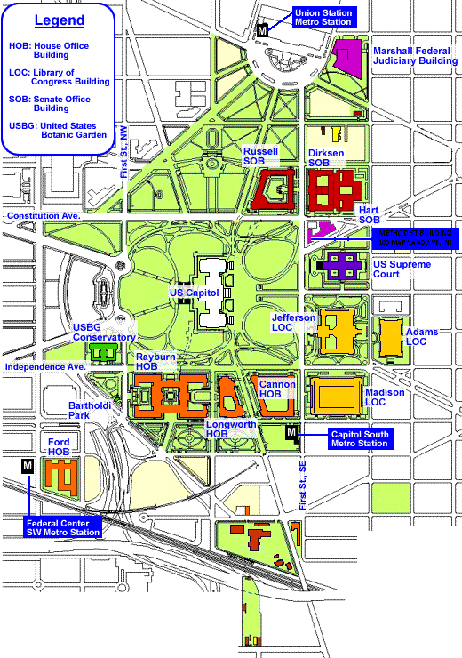

Training and Debriefing
HILL DAY WEBINARS
This year, CJJ will be hosting two Hill Day Training sessions for members on the web. These webinars will take place Thursday, May 14, 2014 from 3-4:00PM and Wednesday, June 4 from 3-4:00PM. The trainings will also be posted on CJJ’s website at juvjustice.org for participants to view at their leisure. The sessions will include a few short presentations about what to expect from a hill visit and how to effectively deliver your message during a visit. Following the presentations, we will have time for a question and answer session. Staff will also be on hand to answer your Hill Day questions on Wednesday, June 18 from 7-9:00 AM.

POST-HILL DAY SURVEY
The Post-Hill Day Survey is especially important for CJJ’s federal outreach. It helps us identify which representatives support our policy agenda, and who we need to target for follow-up outreach. We appreciate your attention to this important part of CJJ’s government relations and will be sure to provide you with more information about the survey after the conference.

HILL DAY MATERIALS
Hill day materials will be available for pick up on site. Please let Naomi Smoot (smoot@juvjustice.org) know how many copies you will need by June 5, 2014. We will be reminding you of this deadline as the conference approaches.

Meeting With Your Member of Congress:

BEFORE THE VISIT

- Call each of your Representatives’ D.C. offices to acquire the name and contact information of the scheduler for each Senator and Representative. Visit http://senate.gov/ and http://www.house.gov/ to identify your representatives.

- Prepare and e-mail or fax letters (do not mail!) requesting appointments for your SAG representative(s) to meet with the Member of Congress of their senior staff person on juvenile justice matters. CJJ Hill Day is Wednesday, June 18, 2014. Also include who will be calling their office for an appointment in your request. (Sample A)

- Follow-up within 48 hours by calling each scheduler, referencing your letter and requesting an appointment. Let them know the name(s) of the constituent(s) from their area/district who will be visiting.

- If possible, schedule appointments within the same building approximately 30 minutes apart. If you have to go to another building, allow 45 minutes. Your visiting schedule is more workable if appointments are scheduled back-to-back in the morning, followed by a lunch break, and then back-to-back in the afternoon. Be sure to allow at least 40 minutes of travel time from Woodley Park to Capitol Hill by Metro Rail.

- After appointments are made, prepare and e-mail or fax letters to persons with whom appointments are scheduled confirming date, time, and name(s) of your SAG representative(s) who will be visiting. (Sample B)

DURING THE VISIT

- Carry no less than two (2) sets of materials to each visit—one for your Representative and one for the staff member who works closely with the Representative on the issue.

AFTER THE VISIT

- After visits are made, prepare and e-mail or fax thank you letters to members expressing appreciation for meeting with you. If you met with a staff member, the letter should be addressed to the Member with a carbon copy to the staff person you visited. (Sample C)

Top Ten Tips for Meeting With

Your Member of Congress
- Be prepared and on time. Give yourself plenty of time to locate the right building, go through security, find your way to the office, and announce yourself to the staff assistant.
- Be brief and clear. Do not assume that the member or staffer is knowledgeable about the issue you are discussing; be sure to provide some brief background information. Use the CJJ Hill Packet to ensure you and your colleagues stay on message.
- Provide a personal story or real-life illustration. Sharing your personal experience as a SAG Member, provider, parent and/or concerned citizen helps to make a personal connection with members of Congress and their staff.
- Be polite and listen carefully. Being respectful, providing reliable information and making a compelling case has helped us win over some terrific champions.
- Be sure to get a response. Ask directly and politely for the policymaker’s views and position on each issue and what s/he plans to do about it.
- Provide information. Bring the CJJ Hill Packet, and other state-specific materials that you have prepared, with you to leave behind at the conclusion of the meeting. Check out the CJJ website for additional valuable resources.
- Give – and get – contact information. Be sure to leave your business card, and to get a business card from the Member/staffer so that you each know how to reach the other. Be sure to ask the Member/staffer their preferred mode of communication (e.g., e-mail, fax, voicemail/phone).
- Summarize your requests of the Member and any responses the Member or staffer has provided to ensure you are clear on where they stand on the issues.
- Report back to CJJ a summary of your meeting. This information is essential for CJJ staff to have so that we can follow up with the office. Complete the CJJ Hill Day Survey and e-mail to smoot@juvjustice.org or fax to 202-887-0738.
- Follow up with a thank-you note. This letter should be addressed to the Member of Congress you visited, with a cc: to the staffer with whom you met. Your follow-up letter should express appreciation for the time and consideration extended to you during your meeting. Reiterate your request(s) and ask for a written response from the office.

Keep This is Mind:
The congressional schedule is very fluid and members of Congress and staffers are often pulled away for last-minute, unplanned activities. As such, your meeting could be delayed or canceled. Additionally, space on Capitol Hill is at a premium, so your meeting could take place in the office reception area, in the hallway or downstairs in the cafeteria. Do not take any last minute meeting changes personally, and make sure you are always gracious and flexible.

Post Hill Day Survey
Instructions: Please fill out one survey for each Member of Congress’ office that you visited. There will be a place for you to turn in the surveys at the registration table at the conference, or you can email (smoot@juvjustice.org) or fax ((202)-887-0738) the survey to CJJ. You should also direct any questions you may have to Naomi Smoot. Naomi can be reached at (202) 467-0864 ext. 109 or smoot@juvjustice.org. We appreciate your assistance in providing feedback about Hill Day 2014.
Contact Information
Name: Phone:
Organization: Email:
State:
About Your Meeting
- Meeting with Senator/Representative_________________________________________

- Congressional Staff Present:_________________________________________________

- Was the meeting with the Member or staff?____________________________________

- Please provide contact information for the person you met with:

Name:_______________________________________________
Email:_______________________________________________
Phone:_______________________________________________

- What issues did you discuss?
  - Reauthorizing JJDPA
  - Restoring appropriations for juvenile justice programs
  - Reauthorizing Juvenile Accountability Block Grant (JABG)
  - Enacting Youth PROMISE Act
  - School to Prison Pipeline
  - Other:___________________________________________________________
- Did the Member/staffer agree to take action on a specific issue?
- Yes
- No
- Maybe

- If yes, what did they agree to? If maybe or no, did they say why?

- How do you think the meeting went? What else would you like to share about the meeting with CJJ staff?

- Would you like to work with CJJ on follow up with this Representative?
- Yes
- No
If Yes, how?

- What did you think about the on-site the Hill Day Training? Is this something we should do again?

- Are there any additional materials that you think would have been helpful for your meetings that CJJ should provide next year?

- Additional questions or comments:

SAMPLES

This information is generously provided to the CJJ Government Relations Committee by the Tennessee Commission on Children and Youth (TN SAG).

SAMPLE A
Official Agency Letterhead

March 4, 2008

ATTENTION: «scheduler»
The Honorable «name»
United States «title» [Senate or House of Representatives]
«address»
Washington, DC «zip»

VIA FAX: «fax»

Dear «salut»:

The purpose of this letter is to request an appointment for representatives of the [SAG or agency home] to meet with you on «date». If you are unavailable, we would like to meet with a key member of your staff who handles juvenile justice/children’s services and appropriations issues. Representatives of the [SAG or agency home] will be in Washington to attend the National Coalition for Juvenile Justice Annual meeting and will be attempting, as we have in previous years, to visit each of our legislators’ offices while in Washington.

As I believe you know, the [SAG or agency home] is a State agency with the primary mission of advocacy on behalf of children and families. We have previously provided you some of the publications we prepare that should be beneficial in addressing children's issues and identifying their impact on [your State], and as we usually do, we will bring you any new ones on this visit. Additionally, the [SAG or agency home] is responsible for implementation of the federal Juvenile Justice and Delinquency Prevention Act (JJDPA) in [your State], which is due to be reauthorized in 2009.

We would appreciate the opportunity to meet with you or a key member of your staff to discuss the upcoming reauthorization of the JJDPA, related federal juvenile justice funding and the impact the Act has had and continues to have in [your State]. [Name of contact] will call your office to schedule an appointment. We look forward to seeing you in April. If we can provide you with additional information or assistance, please contact me.

Sincerely,

SAMPLE B
Official Agency Letterhead

March 12, 2008

ATTENTION: [Name and Title of Staffer you will be meeting with]

The Honorable «name»
United States «title» [Senate or House of Representatives]
«address»
Washington, DC «zip»

VIA FAX: «fax»

Dear «salut»:

The purpose of this letter is to confirm that the following four representatives of the Tennessee Commission on Children and Youth have an appointment to meet with Scott Fischer on «date»:

COMMISSION MEMBERS: Dana Lesley, Chattanooga
Joetta Yarbro, Dyersburg
STAFF: Linda O’Neal, Executive Director, Nashville
Debrah Stafford, Juvenile Justice Director, Nashville

Representatives of the Commission will be in Washington to attend the National Coalition for Juvenile Justice Annual meeting and may be reached by calling «phone».

As I believe you know, the Tennessee Commission on Children and Youth is a State agency with the primary mission of advocacy on behalf of children and families. We have previously brought you some of the publications we prepare that should be beneficial in addressing children's issues and identifying their impact in Tennessee, and will bring any new ones we have to this visit.

The Commission on Children and Youth is responsible for implementation of the federal Juvenile Justice and Delinquency Prevention Act (JJDPA) in Tennessee. We would like to discuss the impact of this federal legislation in Tennessee, its reauthorization and related federal juvenile justice funding. Representatives of the Commission hope to meet with all members of the Tennessee Congressional delegation. Consequently, we had a scheduling challenge to coordinate this process. Faye Mangrum with the Commission staff called your office to schedule this appointment, and we appreciate your staff working with us in scheduling. We look forward to seeing Scott Fischer on «date» If there are ways we can provide you with additional information or assistance please contact me.

Sincerely,

SAMPLE C

Official Agency Letterhead

April 30, 2008

The Honorable «name»
United States «title» [Senate or House or Representatives]
«address»
Washington, DC «zip»

VIA FAX: «fax»

Dear «salut»: [Senator _______ or Congressman/woman ___________ ]

We appreciate «name1» on your staff meeting with representatives of the Tennessee Commission on Children and Youth on «date» to talk about reauthorization of the Juvenile Justice and Delinquency Prevention Act (JJDPA) and related federal juvenile justice funding. We were glad to have the opportunity to provide you with substantial amounts of information about the positive impact these funds have had in Tennessee.

As we discussed during our conversation with «name2», we are particularly concerned about the reduced appropriations for the Juvenile Accountability Block Grant (JABG). Three-fourths of these funds are passed through to local units of government for accountability-based programs, and the remaining funds are allocated through a competitive grant process to serve areas in Tennessee that are not eligible for the pass-through funding.

We hope the final JJDPA reauthorization bill and Commerce/Justice/Science budget will include important juvenile justice funding and urge your support for the reauthorization and for these funds that make so much difference to communities across Tennessee and the nation.

If we can provide you with information or assistance, please let us know. Tennessee critically needs federal juvenile justice funding.

Sincerely,

cc: «cc»

