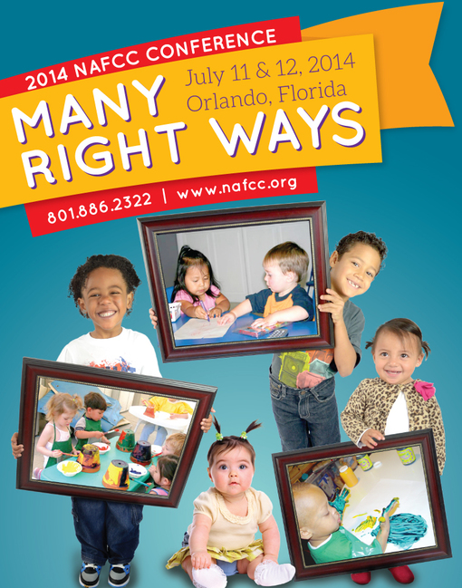

The National Association for Family Child Care Presents:
The Second Annual Family Child Care Innovator Awards
"Recognizing Exceptional Work to Combat Childhood Obesity in Family Child Care"
The National Association for Family Child Care (NAFCC) is a strong partner in the Let’s Move! Child Care (LMCC) initiative. LMCC was launched by First Lady Michelle Obama in June 2011 with the goal of helping children learn habits that prevent childhood obesity and can keep them healthy for life. LMCC provides tips, webinars, and other online resources for child care providers focused on the following goals: increasing physical activity, reducing screen time, improving food and beverage choices, and supporting infant feeding.
In partnership with the Office of Child Care (OCC), NAFCC is excited to announce an open call for nominations for family child care providers to be recognized for exceptional work promoting and implementing the goals of LMCC. Family child care nominees must be able to demonstrate creative and innovative activities in their family child care programs that engage children in healthy eating, physical activity, and/or screen time best practices. Five family child care providers will be recognized during the Tribute to Family Child Care at the NAFCC National Conference, July 11, 2014 in Orlando, FL. Self-nominations are permitted.
Eligibility Requirements--All nominees must:
- Be legally operating family child care providers. (Please include your license number and monitoring agency.)
- Members of NAFCC.
- Participants in LMCC. (A copy of your certificate must be submitted with your nomination. A copy of your completed LMCC Checklist Quiz must also be submitted with your nomination.)
To complete a nomination, submit a written description (maximum 500 words) demonstrating your program’s creative and innovative work around the LMCC goals. Please include a PowerPoint presentation (maximum 10 slides) about your program and your participation in LMCC. Please do NOT include videos, links to other sites, or sound in your PowerPoint.
All nominations (including written descriptions and PowerPoint presentations) must be received by May 23, 2014. Please submit nominations by e-mail only to BSawyer@nafcc-mail.org.

