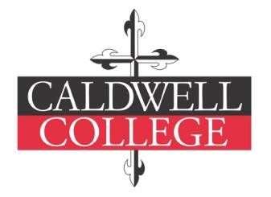
Caldwell College Archives Deed of Gift
Please fill out the following form and include with your submission of
your Caldwell College memorabilia.

Personal Information
Name: Class Year:
Maiden name:
Address:
City: _ _ State: Zip:
Home phone: Cell phone:_____________________________
Email:
Information about the Memorabilia
Estimated year of memorabilia:
Description of donation and how the materials came to be in your custody:

Rights of Disposition
Caldwell College may use its discretion in disposing of materials considered inappropriate for archival retention unless instructions to return any unwanted materials are stated below.

Caldwell College may dispose of unwanted items Caldwell College must return unwanted items to donor
Terms of Agreement
This donation has been received by Caldwell College (“College”) as a gift for use in the Caldwell College Archives, and the owner or her agent with full authority, desiring to absolutely transfer full title by signing below, hereby gives, assigns, and conveys finally and completely, and without any limitation or reservation, full and complete ownership of the property described above to the College for use in the Archives and its successors and assigns permanently and forever, together with any copyrights therein and the right to copyright the same.

Signature of Donor Date

Signature of Archivist Date

