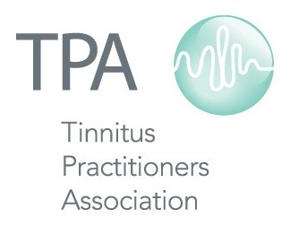

Tinnitus Practitioners Association
2014-15 Schedule of Courses and Conferences

Feb 21-22 Misophonia Conference Atlanta, GA
Apr 11-12 Fellow Course St. Louis, MO
Jun 20-21 Associate Course Chicago, IL
Aug 8-9 Fellow Course San Francisco, CA
Sep 5-6 Associate Course Houston, TX
Jan 19-20 Associate Course Maui, HI
Feb Misophonia Conference TBD
Mar 13-14 Fellow Course New York City, NY

Visit www.tinnituspractitioners.org for more information
or contact us by email at tpa_office@snet.net

