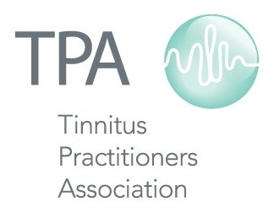

Tinnitus Practitioners Association
2014-15 Schedule of Courses and Conferences

Feb 21-22 Misophonia Conference Atlanta, GA
Apr 11-12 Fellow Course St. Louis, MO
Jun 20-21 Associate Course Chicago, IL
Jun 25-26 Associate Course Chicago, IL
Aug 8-9 Fellow Course San Francisco, CA
Aug 21-22 Associate Course Harrisburg, PA
TBD Associate Course TBD
Jan 19-20 Associate Course Maui, HI
Feb 20-21 Misophonia Conference Phoenix, AZ
Mar 13-14 Fellow Course New York City, NY

Visit www.tinnituspractitioners.org for more information
or contact us by email at tpa_office@snet.net

