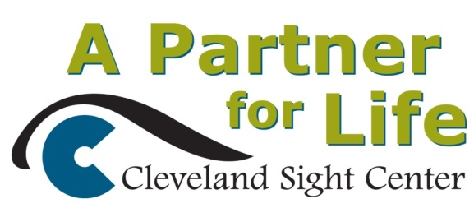
Cleveland Sight Center Receives Gift
The Cleveland Sight Center received its largest gift ever when philanthropists Corrine and Alan Reid gave the agency a $2 million endowment check, said Patrick Ertle, chief development officer. The gift will endow the position of Director of Children and Young Adult Services, which includes the Bright Futures Early Intervention and Preschool programs. To recognize the award, the agency will rename its Children’s Services Wing in the Reids’ honor. “Growing our endowment is key to the future strength of our agency,” said Steven Friedman, president and executive director of the Sight Center. "In addition, Friday's benefit raised over $100,000 for our Empowerment Fund, through which we can help clients purchase adaptive aids which they otherwise could not afford and which can make an enormous difference in their lives."

