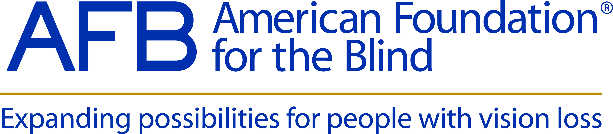
Be an Advocate: Help Strengthen Specialized Services for the Blind
As advocates for people who are blind or visually impaired, the American Foundation for the Blind (AFB) knows first-hand the value of specialized services. They change lives by teaching people with vision loss the skills needed to thrive in the classroom, the workplace and everyday life. Yet, these services are almost perpetually in danger of being cut due to shrinking state budgets. It is therefore crucial that we continue to advocate to our policymakers of their importance, and to ensure such services are kept in place.
To that end, AFB has created new advocacy materials on strengthening specialized services that we hope you will share with your constituents. On AFB.org, you can find an overview of specialized services as well as specific documents on education services, employment services, and services for adults with age-related vision loss. These documents are also available as accessible PDFs that can easily be printed and shared.
We created these materials to help educate the public about the importance of specialized services. Help us spread the word today!
How you can help:
- Share AFB’s specialized services advocacy materials with professionals in the field, people with vision loss and their loved ones, and your elected officials.
- Post a link to the specialized services advocacy materials on your website and social media channels.
- Share these materials in your newsletters and outreach materials.

