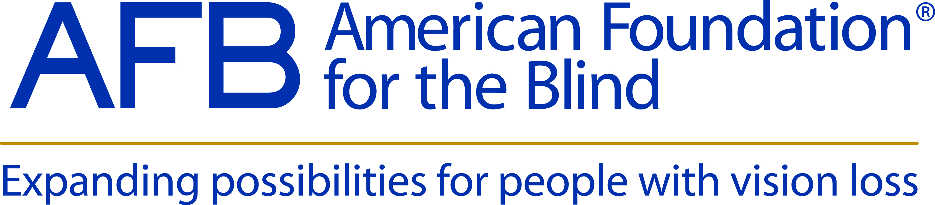

AFB To Team with VSA to Expand Leadership Training

AFB is proud to team with the VisionServe Alliance for the 2014 AFB Leadership Conference in New York, to be held February 27-March 1. The VisionServe Alliance has put together an intensive leadership training track that will be open to all conference attendees. Come sharpen your skills or learn how you can become an effective leader.

Book a room at the marvelous New York Marriott at the Brooklyn Bridge for just $189/night with our special group rate. This rate is good from Wednesday, February 26, through Monday, March 3, so stay a while and explore the city that never sleeps! This discounted rate disappears on February 1, 2014, so make your reservation today. If you would prefer to make your reservation by phone, call 1-888-436-3759 and let the operator know that you are attending the conference.

Conference registration is now open and takes just minutes, so register today!

