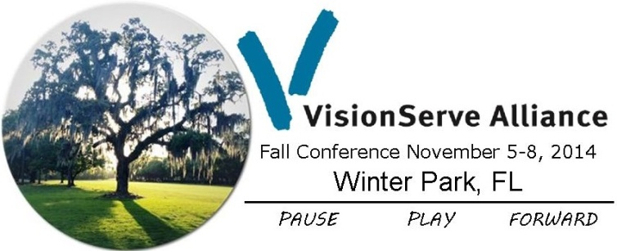
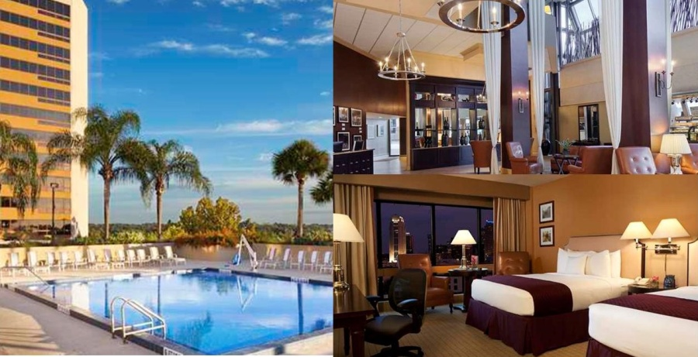

Double Tree by Hilton
60 S Ivanhoe Blvd
Orlando, FL. 32804
Phone 407-425-4455

http://tinyurl.com/bw-WinterPark

To guarantee your rate of $169 per night please follow these steps:
- Call the hotel at 407-425-4455
- Tell them you’re with VisionServe Alliance
- Book your dates

Hotel deadline is October 5, 2014.

Local Airport:

Orlando International Airport http://www.orlandoairports.net/

Transportation to/from Hotel:

George the Driver is available by reservation: Call 407-369-2253 or email viamontanez@gmail.com, say you’re with the “VisionServe Conference.” Fare from airport to Alfond Inn: Sedan $60, SUV $65, Van $70. George will group those arriving at approximately the same time for fare sharing.

Taxi rates are approximately $52 from Orlando International Airport to Alfond Inn.

Uber Car is available is Orlando. The quoted fare is $31-$42. To learn more click the link provided https://www.uber.com/cities/orlando

