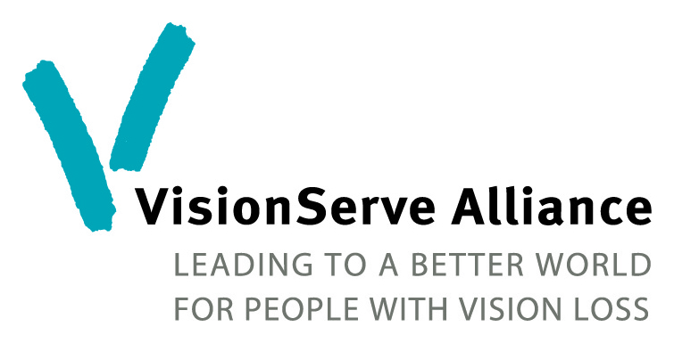
Winter Park, Florida
Abbreviated Agenda – High Level Program Directors

Wednesday, November 5th
7:00 pm Welcome Reception

Thursday, November 6th
6:30 am Run/Walk-Optional
7:00-8:30 am Breakfast Coupon – Hamilton’s Kitchen
9:00 am Welcome and Introductions
9:30 am Listening Pays
10:45 am Speaking Like You Mean It
12:00 pm Walk to Polasek Museum – Networking Lunch
1:45 pm Welcome and Introductions
2:00 pm Update on Evidence Based Outcomes Project
3:00 pm Break
3:15 pm Building a Relationship with Partners and Funders
4:30 pm Personal Time
6:30 pm Restaurant Dine-Around
“
Friday, November 7th
6:30 am Run/Walk -Optional
7:00-8:00 am Breakfast Coupon – Hamilton’s Kitchen
8:30 am What Keeps You Awake at Night? Open Discussion.
9:30 am “Spiel and Steal” Best Practices
10:30 AM Break
10:45 am Best Practices continues
11:45 am Tour and Lunch at Lighthouse Central Florida
3:00 pm Rebranding and Renaming – Feedback to Hadley
4:45 pm Depart for Cocktail Boat Tour of Old Florida
6:30 pm Fantastic Florida Party and Awards featuring Running with Scissors

Saturday, November 8th
7:30 – 9:00 am Breakfast Coupon – Hamilton’s Kitchen

