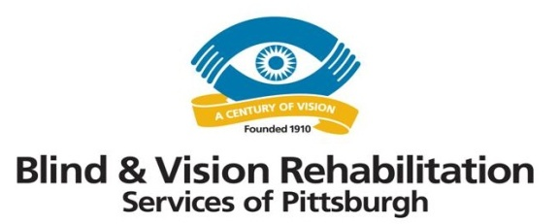
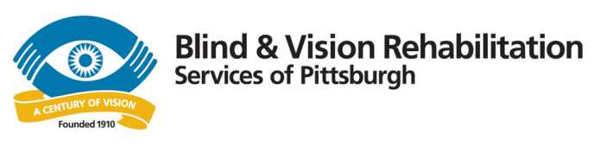
Partnership Addresses Health and Home Safety Needs of Seniors

With funding from the local United Way, two Western Pennsylvania nonprofits – Blind & Vision Rehabilitation Services of Pittsburgh and Rebuilding Together Pittsburgh – have joined forces to better serve the health and home safety needs of seniors in their service area. The program helps seniors with vision problems by providing counseling, caregiver instruction and home modification.

In addition, the HomeSafeHome collaboration offers training videos and checklists to help caregivers, family members and volunteers assess the homes of seniors and make improvements that will increase safety and decrease risk to the resident. Each training video and accompanying checklist identifies issues that could be hazardous in the home. Four of the videos cover a different area of the home – bathrooms, kitchens, stairs and outdoor areas – and identify both problems and potential solutions. For example, the bathroom can be difficult to navigate for seniors and people with vision impairment. A few quick fixes, such as installing grab bars in the tub, can go a long way.

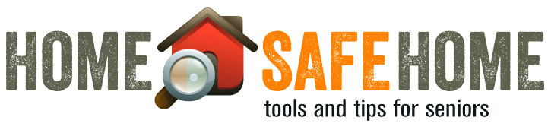
A fifth video demonstrates how to test for vision loss and is accompanied by an Amsler grid. Videos and checklists can be viewed at www.bvrspittsburgh.org/services/services-for-seniors/home-safe-home/.
For additional information, contact Barbara Peterson, 412-368-4400 ext. 2245 or bpeterson@pghvis.org.

