PERKINS CELEBRATES 185 YEARS
A trip to Paris to see the world's first school for the blind in the early 1820s convinced medical student John Dix Fisher of the dire need for such a school in America. On a cold February day in 1829, Dr. Fisher brought together a group of prominent Bostonians to incorporate the New England Asylum for the Blind. On March 2, 1829, the Massachusetts legislature unanimously approved the incorporation and appropriated $6,000 a year for 20 students' tuition. Using rooms in his father's Boston home for classes, Perkins' first director Samuel Gridley Howe opened the doors of the school in 1832.
Throughout our 185-year history, Perkins has been an innovator in education for the blind, acting as a pioneer both in the U.S. and abroad. Some of our Perkins "firsts" include:
● First school for people who are blind chartered in the United States (1829).
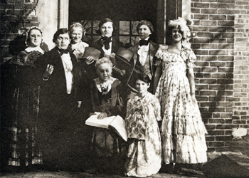
● First school to formally educate a person with deafblindness (Laura Bridgman, 1837).
● First kindergarten for children who are blind (1887).
● First to provide education for families of babies who are blind in Massachusetts (1945).
● First training program in Africa for teachers of students who are deafblind (2007).
● First mechanical braillewriter with instantaneous audio and visual feedback (2012).
Today, Perkins continues to expand on its founders' idea that all children who are blind, deafblind or visually impaired deserve an education and can lead meaningful, productive lives. Now as then, Perkins seeks to create a total earning environment—providing academics, vocational training, help with daily-living skills and social and recreational opportunities for students on campus, in the community and in 67 countries around the world.
Students from Fisher Cottage reenact the founding of Perkins by Dr. John Dix Fisher circa 1932 in honor of the school's hundredth year in operation.

Students from Fisher Cottage reenact the founding of Perkins by Dr. John Dix Fisher circa 1932 in honor of the school's hundredth year in operation.

