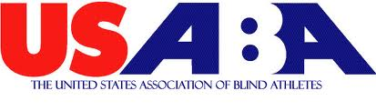
More Than 800 to Participate in USABA
National Fitness Challenge

Thanks to a generous $220,000 grant from the WellPoint Foundation, the United States Association of Blind Athletes (USABA) is pleased to implement the National Fitness Challenge for the third consecutive year.

USABA will partner with 39 agencies throughout the United States to provide more than 800 blind and visually impaired individuals with an opportunity to increase their physical fitness levels, and live healthier more active lives.

The goal is to raise activity levels to that recommended by the CDC. The use of technology and social media will help set goals, create team environments and encourage leadership. USABA will provide participants with a Nike+ FuelBand Silver Edition (SE).

Individuals who participate in regular physical activity have higher energy levels, a lower risk of health-related diseases, improved psychological health, and lower rates of depression and anxiety. Unfortunately, because of the numerous barriers and misconceptions about their abilities, more than half of those who are blind and visually impaired in the United States do not participate in even a limited physical activity regimen.

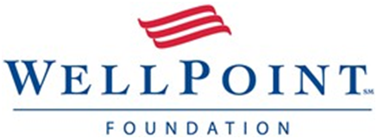
“Through this program, the USABA, the WellPoint Foundation and all of the participating agencies are breaking down these barriers and leveling the playing field for people who are blind and visually impaired,” said Mark Lucas, executive director of USABA. “During the past two years, this program has reached more than 1,200 blind and visually impaired people around the U.S., reducing the body mass index of more than 70 percent of the participants. By integrating the use of technology, these numbers will drastically grow.”

