Call for Proposals in Youth Goalball

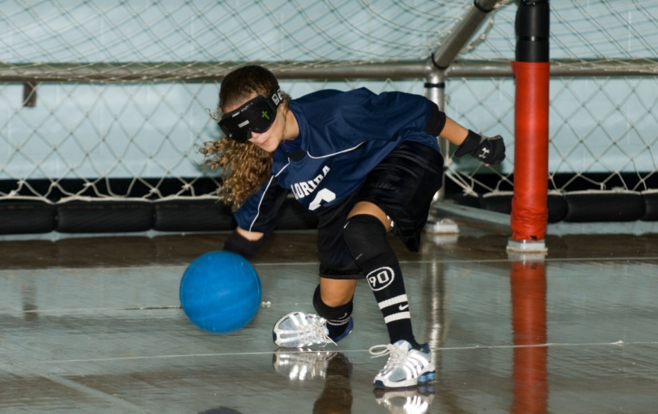
The United States Association of Blind Athletes (USABA) is extending its already lengthy reach into the game of goalball. USABA, which manages high performance goalball in the United States, including the development of Paralympic players, is seeking partners across the country to start new youth teams in a nationwide grassroots effort.

Goalball is a sport for athletes who are blind or visually impaired. The game pits three athletes to a side on an indoor court, with two nets stretched along the floor’s width. Players roll the ball, which is full of bells, thereby mandating silence, back and forth in an attempt to score.

USABA is looking for interested athletes of all skill levels and ages. The organization will partner with interested agencies and provide resources, including more than $1,000 for technical startup costs, necessary equipment and access to USABA’s expert goalball coaches and training videos.

For more information on this grassroots program, please contact Matt Simpson, USABA Membership and Outreach Coordinator, at msimpson@usaba.org or 719-866-3019.

