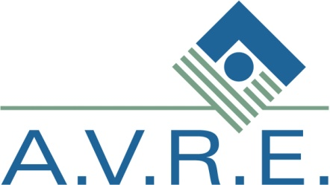
AVRE Kicks Off National Fitness Challenge

Through a partnership with the USABA and the WellPoint Foundation, AVRE is participating in a national fitness challenge geared toward increasing physical activity and improving overall health.

Over 800 individuals who are blind or visually impaired from around the country will participate in the 7 month long challenge. Twenty employees, including AVRE’s Board Chair, Kelly Storm, and CEO Ken Fernald, are equipped with a Nike+ Fuelband that monitors physical activity. Prizes and incentives will be awarded throughout the challenge to encourage some friendly competition!

As part of their personal fitness challenge, CEO Ken Fernald and Production Supervisor Luigi Di Russo are working with Positive LifeForce of Endwell to train for this year’s Greater Binghamton Chamber of Commerce’s Bridge Run. Fernald’s training is sponsored by Positive LifeForce and the Chamber. Fernald will run in the half marathon and DiRusso will run in the 5k with his daughter.

Very new research suggests that increased physical activity may actually slow the progression of retinal eye diseases. Unfortunately, because of numerous barriers, more than half of those who are blind or visually impaired in the United States do not participate in even limited physical activity.

