# After 30 years, Lighthouse focused on future

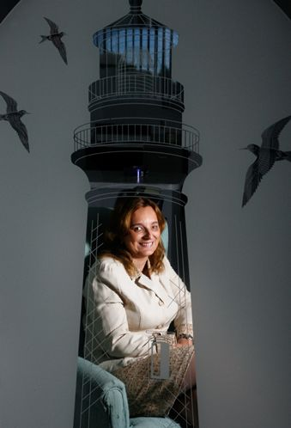

“Every day we see more sophisticated computers and other inventions that ease the burden of all disabilities.” Sylvia Stinson Perez, executive director

The Lighthouse for the Visually Impaired and Blind turned 30 this year, setting off a series of celebrations and recognition of how far it has come since the days when a hard summer rain would flood its tiny building.

Volunteers often became the "mop brigade,'' but this still beat the alternative — driving to Tampa or St. Petersburg for service.

Three decades later, the place that began with a $500 donation in 1983 now has a $1.2 million budget and modern facilities in Pasco and Hernando counties. It is thriving and providing independent living skills for people, babies to seniors. And it is entering an exciting era focused on providing manufacturing jobs and training.

All of which might make this prediction for the next 30 years a bit surprising — until you think about it.

"By then, I hope we would be out of business,'' said Sylvia Stinson Perez, who has run the nonprofit agency the last five years.

Perez, 44, has spent most of her life legally blind with a degenerative eye disease called retinitis pigmentosa. But steady and often miraculous advances in medical science and technology have enabled her to excel academically and professionally in a world where more than 70 percent of sight-impaired adults can't find jobs.

"I believe in 30 years, we'll have prevention and cures that don't exist today,'' she said. "Every day we see more sophisticated computers and other inventions that ease the burden of all disabilities.''

Perez reckons the Lighthouse has served more than 20,000 people in the three decades. Ninety percent of them developed conditions like glaucoma and macular degeneration that attacked their vision and left them needing to learn how to adjust. Many others, sadly including babies and children, suffered blindness amid other disabilities.

Lighthouse vans covered 92,000 miles this year picking up and delivering clients to training centers in Port Richey and Brooksville. Other folks got help in their homes. They received counseling and training for tasks once so ordinary — managing medicines, crossing streets safely, shopping at the grocery store. They learned how to mark their stoves and phones, how to read with their fingers.

Shortly after she arrived, Perez started a program aimed at teens who received intensive training on computers and other technology. "Technology,'' she said, "is the great equalizer.'' Twenty-five teens have gone through the program, many becoming friends. Several have graduated from high school.

Today, most of the excitement centers on trash can liners produced by Envisions, a Kansas company that is a national leader in providing jobs for sight-impaired people. It has contracted to send cases of the liners to the Lighthouse, where clients will learn how to repackage, label, market and ship.

The Lighthouse Opportunity Center is a former printing plant on Pine Hill Road in Port Richey secured in part through a grant by the National Industries for the Blind. Since it opened in April, a few clients have found work packaging a device that releases a fragrant mist. But more recently, the Lighthouse worked a deal for cotton workshop towels and the trash liners.

Peter James, inspired last year by the way Lighthouse programs helped his daughter Lily after she was born with a vision impairment, has been hired as director of business development. He envisions the center buzzing soon with workers packaging and shipping the liners and other products.

Perez believes that center will not only provide jobs, it will also bring in revenue. The Lighthouse receives 60 percent of its funding from the state Division of Blind Services, but depends heavily on donations. The manufacturing center, Perez hopes, will help the agency achieve what it seeks to give its clients: independence.

"Trash bags today,'' she says, "who knows what tomorrow? We're looking for other opportunities. We're open to ideas.''