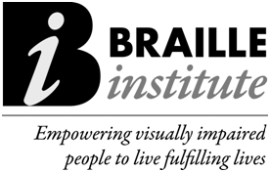
‘DIGITAL DOTS’ EXPANDS SPECIAL COLLECTION PROGRAM TO HIGH SCHOOL STUDENTS
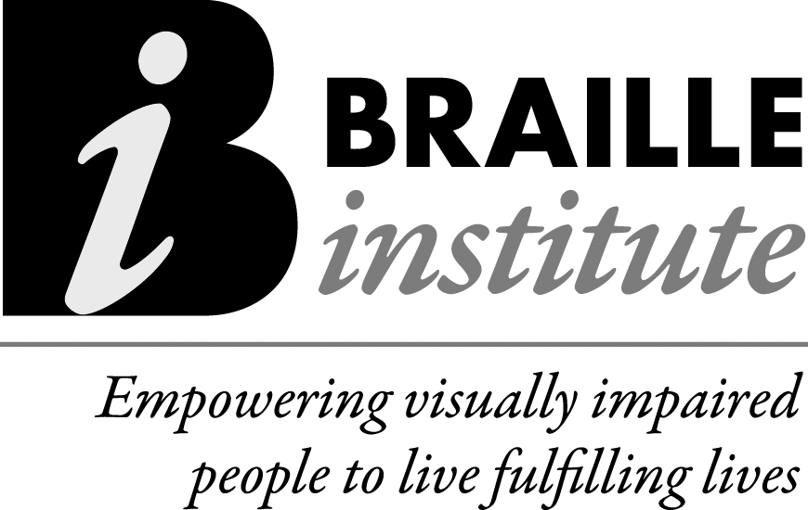
Thanks to a generous donation from the University of California, Los Angeles Division of Undergraduate Education, BIA will be expanding its Special Collection of free books in braille to students in grades 10-12 through their new Digital Dots program this Fall.
Digital Dots will provide high quality fiction and non-fiction recreational books in an electronic file format that high school students can download to a braille notetaker or computer/tablet with a refreshable braille display—the preferred mode of reading braille for a tech-savvy generation of blind students.
BIA currently has 2,900 titles that rotate in the collection, 400 of which are for this older age group. Those initial titles will launch the program, with more titles added each season as our subscription list of older readers grows. As part of program, BIA will be adding a dedicated web portal and a mobile app to enable subscribers to download books.
Braille Institute created the Braille Special Collection in 1999 to build interest in reading, promote braille literacy and enable children to build their own library of braille books. More than 2,600 families and educators now order books free of charge through BIA’s Collection. Children from pre-school up to 9th grade can choose up to 12 braille books a year from our seasonal catalogs of popular and classic hardcopy titles, or select a title from our Dots for Tots®, Top Dot® or Tactales® series of storybook kits. However, titles offered for older students have been limited due to their size. Many braille books for this age group can be up to 12 volumes. Digital Dots will be provide e-books free of charge to subscribers both in the United States and Canada.
For more information: Call 1-800-BRAILLE and ask for Braille Publishing, or call directly to 323-906-3104, Monday through Friday 9 a.m. to 5 p.m. (PST), or email us at
specialcollection@brailleinstitute.org.

