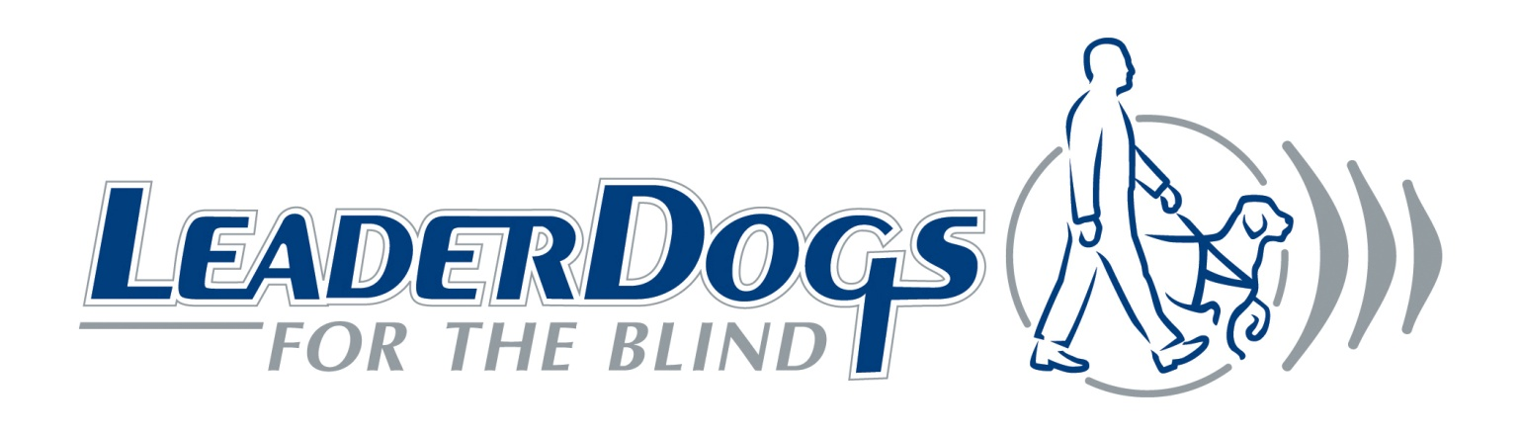
LEADER DOGS FOR THE BLIND RECEIVES AWARD FOR PRISON PUPPY RAISING PROGRAM

Leader Dogs for the Blind received the 2013 Governor Hugh L. Carey Award from Mutual of America Foundation for their Prison Puppy Raising Program. The award honors the outstanding contributions that nonprofit organizations, in partnership with public, private and other social sector organizations, make to society. The award was presented in November, 2012.

In 2002, Leader Dogs for the Blind collaborated with the North Central Correctional Facility in Calhoun County, Iowa to launch the Prison Puppy Raising Program. This groundbreaking partnership pairs puppies with inmates as a first step in preparing guide dogs for the blind and visually impaired. The program now places nearly 100 puppies each year with inmates at six minimum-security prisons in Iowa, Minnesota, Wisconsin and Michigan.

“Puppies raised in our partnering prisons experience a higher success rate of being placed with a client who is blind after Leader Dog training than those raised in a home setting. But it’s not just the puppies and our clients that have benefitted,” explained Susan Daniels, Leader Dog CEO and President. “Inmates who have raised a puppy express pride and gratitude for the chance to give something back to the community. Equally important, the experience seems to change their behavior once they leave prison. There is a marked reduction in the rate of recidivism of inmates who served as puppy raisers.” Leader Dogs for the Blind’s partners in the program are the Iowa Department of Corrections, Lions Clubs International and Purina Pro Plan.

