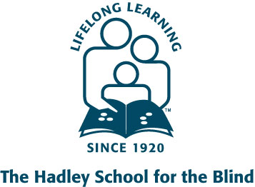

New Resource for VSA Member Agencies: Hadley’s Reinforcing Independence Course
The Hadley School for the Blind recently introduced a new course, Reinforcing Independence: The Role of the Family. Research shows that the most influential people in the rehabilitation process are the family members and loved ones of the visually impaired individual. What does your blindness rehabilitation program offer the sighted loved ones of newly visually impaired clients engaged in learning skills and the related adjustment process? This course is an opportunity for sighted loved ones to learn how to best be supportive and reinforce the skill training and adjustment process.
This tuition-free, two-lesson online course dispels myths and presents facts about visual impairment. It then presents actual ways to encourage and offer support to a relative who is relearning independent living skills. Becoming familiar with information about visual impairment will enable students to promote the independence of relatives who are visually impaired. For more information or to enroll, please visit www.hadley.edu or contact Student Services at 800-526-9909.

