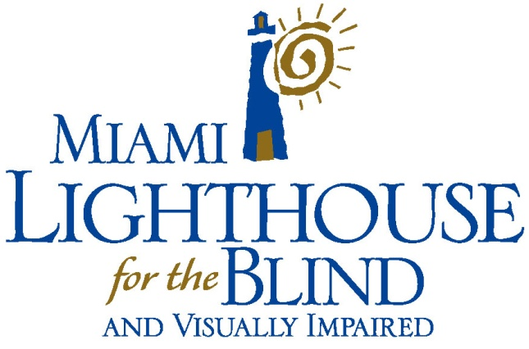
MIAMI LIGHTHOUSE FOR THE BLIND’S JIN HO CHOI RECEIVES PRESTIGIOUS
LIBRARY OF CONGRESS BRAILLE MUSIC TRANCRIBER CERTIFICATION

It is with great pride that Miami Lighthouse announces that Jin Ho Choi, a certified Braille instructor, has received the prestigious Library of Congress Braille Music Transcriber Certification. The curriculum teaches students to transcribe print music materials into Braille.

Blind since age 19, Jin authored and has been teaching the copyrighted course to our students for two years while expanding it for distance learning. This curriculum is a series of Braille music lessons from our nationally acclaimed Better Chance Music Production Program™ which was launched June 1st in a distance learning format. The course enables the Grade 2 Braille reader to learn concepts of musical notation, making it possible for a blind musician or vocalist to have information on sheet music equivalent to what a sighted musician has. Our goal is to provide nationally the Braille music instruction our students receive when attending classes at Miami Lighthouse.

The curriculum features 26 comprehensive lessons for Braille readers and a glossary written by a certified music instructor from Miami-Dade County Public Schools. Each interactive lesson can be completed in 45 minutes, with home learning activities for practice and review. Students submit assignments online for review by Jin. Through our innovative curriculum Jin will open the door for other blind musicians to read Braille sheet music.

For additional information contact:
Virginia Jacko, President & CEO
Miami Lighthouse for the Blind and Visually Impaired
305-856-4176
vjacko@maimilighthouse.org

