Perkins’ Fishing class combines nature’s classroom and favored pastime for life lessons

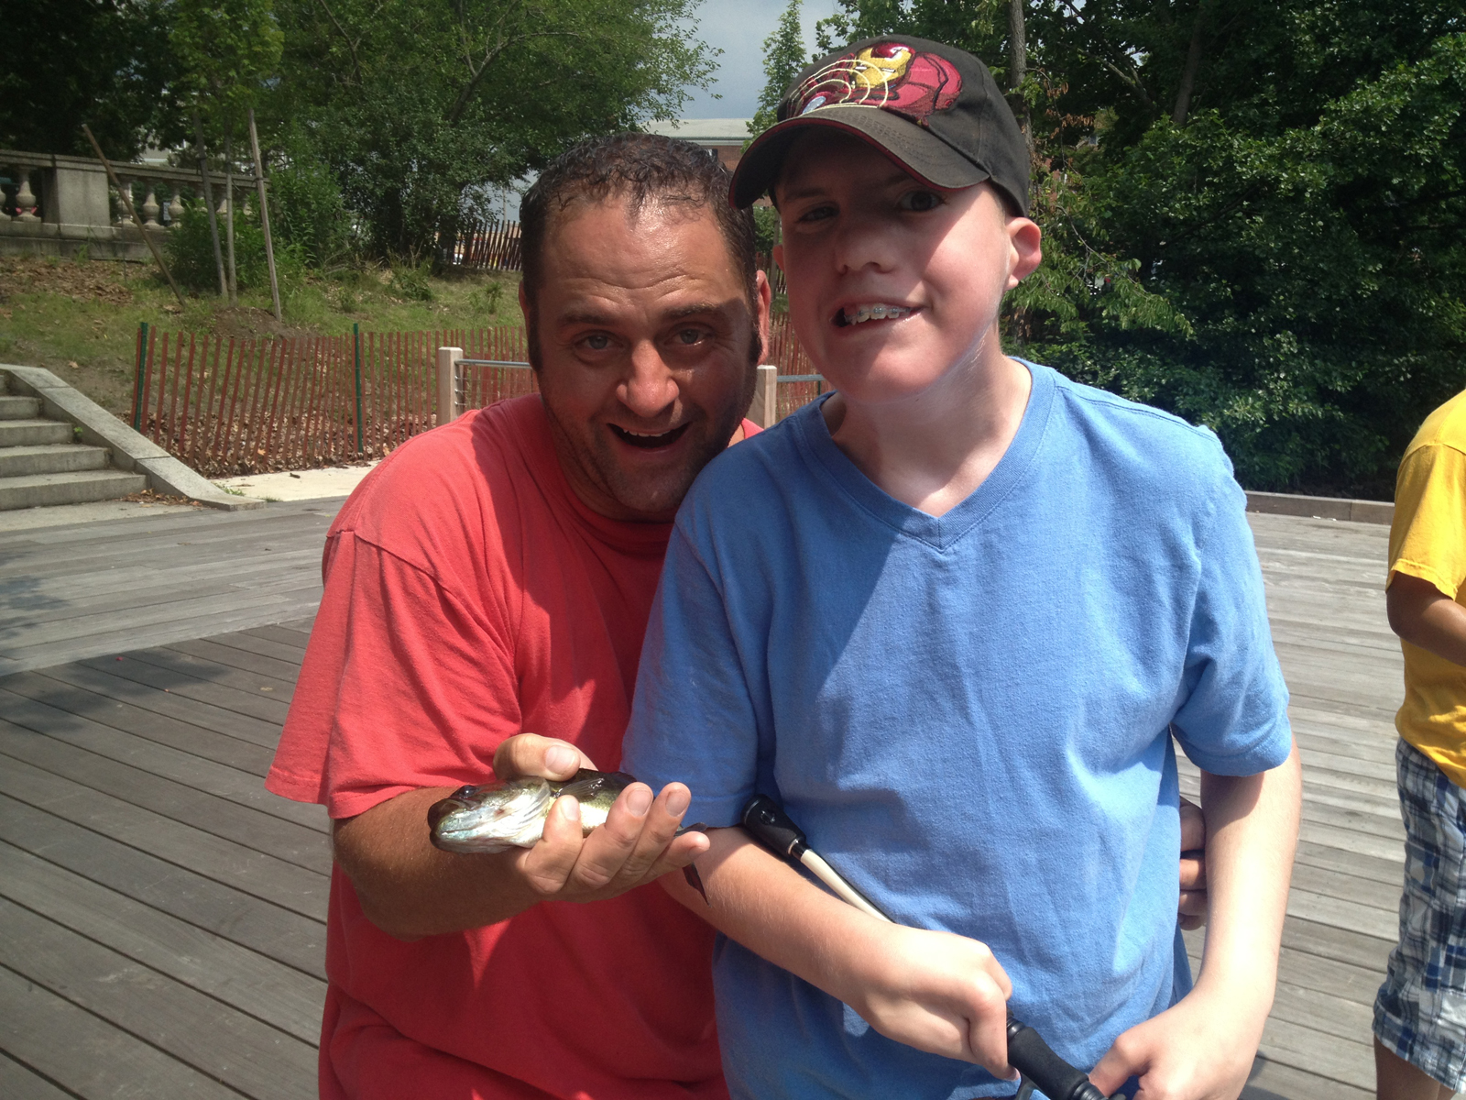

Joel carefully reeled in his fishing line. The 16-year-old had felt a nibble as he sat patiently by the edge of the Watertown Square Dock overlooking the Charles River. With a swift yank, the Perkins Deafblind Program student pulled a foot-long fish onto the wooden dock, where it flapped frantically.

Fellow students and staff screamed with excitement as the smallmouth bass wriggled by their feet. It was the first time anyone had actually caught a fish in the Deafblind Program's inaugural fishing course.

Twice a week over the summer, Deafblind Program teacher Michael Connor took a class of four students down to the dock, which is just a short distance from Perkins School for the Blind's campus. They came to learn about nature and the cycle of life, but stayed for the fun of mastering a new skill while being outdoors with friends.

Adaptive physical education teacher Mike Pecorella snatched the flopping fish from the dock and removed the hook. He held the fish gently so the students could feel its wet scales. He then tossed it back into the water, and the teenagers picked up their fishing rods with renewed optimism.

"Trying to catch a fish!" announced Deafblind student Michael, who eagerly cast his line back into the flowing waters of the river.

Fishing is an ideal activity for students who are deafblind, Connor said, because they don’t need vision or hearing to participate. They can bait a hook or feel a fish on the line using only their sense of touch. And because fishing involves a lot of waiting, the class also encourages kids to practice their social skills.

“We're trying to teach them that independence of calmly sitting there,” Connor said. “There's no rush. The students can just slowly reel in. They don't need a lot of staff assistance."

