**The New Hampshire Association for the Blind honored Concord Hospital**

Concord Hospital is helping produce an innovative new video being used around the country to train caregivers, volunteers and hospital staff members to better serve persons who are blind and visually impaired.

The Hospital earned the Association’s 2013 Blind Access Award for its 18-month collaboration with the Association to produce “How Can I Help You?” The video initially was intended to be distributed to all New Hampshire healthcare facilities and hospitals, but it proved so popular and effective, it now is being widely used nationwide. It also is available worldwide on the Association’s website.

“The commonsense DVD has enhanced access and eliminated barriers to patients and visitors at medical facilities around the state,” said Amy Nichols, of the NHAB. “This new training tool focused specifically for healthcare facilities demonstrate how to assist a person who is blind or visually impaired.”

The Association’s Advocacy Committee identified the need for the specialized training to help its clients and sought the assistance of Concord Hospital, which wholeheartedly supported the important project.

"Concord Hospital was pleased to collaborate with the Association to increase awareness of the special needs of blind and visually impaired,” said Pamela Puleo, Vice President of Community Affairs. "We are very proud that our joint effort is helping healthcare facilities and providers improve medical care and services in New Hampshire and throughout the country."

The New Hampshire Association for the Blind is making this training video available by download on their website at http://sightcenter.org/resources/index.php#Video

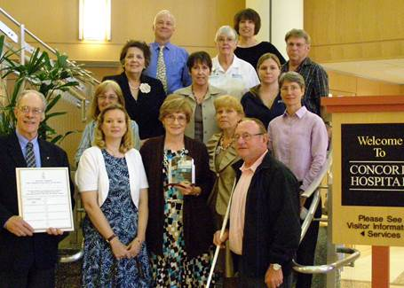

[Pictured: NH Association for the Blind and Concord Hospital staff & volunteers that worked to produce the training video; “How Can I Help You?”]

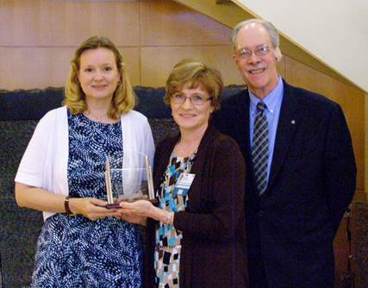

[Pictured from L – R: Amy Nichols, NH Association for the Blind Board Member, Aleta Biladeau, Nursing Supervisor/Educator, George Theriault, President & CEO NH Association for the Blind.]