Students at Md. School for the Blind Enjoy Unique "Show and Tell"

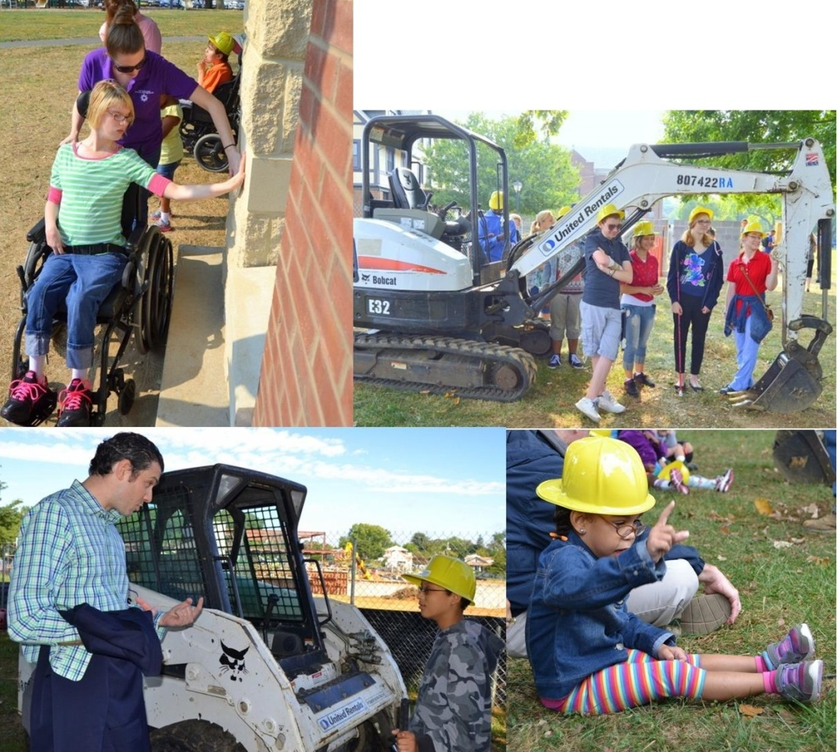
BALTIMORE, Md. - Construction was brought to life for 175 students who are blind or visually impaired during a special presentation of "show and tell" at the Maryland School for the Blind.
The school, along with Lewis Contractors held the special event at the construction site on the school's 100 acre campus in northeast Baltimore.
School officials say students got a hands-on experience with the construction equipment, tools and materials that are being used to build a new learning activity center and residential cottages for them. Officials say the students were able to ask questions to the construction crew and touch materials including bricks, concrete, stones and insulation.
School officials say the presentation was a unique sensory experience for the students and brought the construction process to life, as well as gave them a personal connection.
In a released statement, members of Lewis Contractors said they were equally excited to share their expertise with the students. "It was a pleasure hosting these interactive days and makes us all very happy," said Tyler Tate, president of Lewis Contractors.
The Maryland School for the Blind serves 73 percent of the 1,800 students identified in Maryland who're blind or visually impaired from birth to 21-years-old.
**Photos courtesy of the Maryland School for the Blind.

