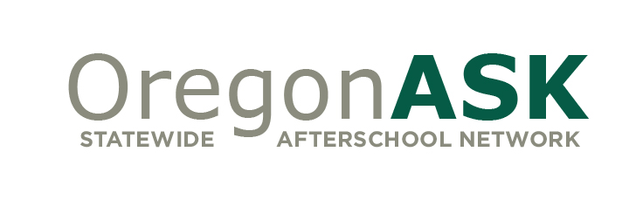

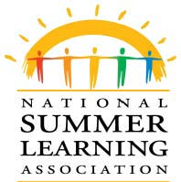
SL³
School Libraries, Summer Learning, Summer Lunch

Opening Doors, Expanding Minds, Nourishing Bodies
Summer 2014 - Interest Form

Are you interested in participating in the SL³: School Libraries, Summer Learning, Summer Lunch Project, and supporting student success during summer months? If so, please fill out this Interest Form and return to Lynn Kneeland at lynn.kneeland@oregonask.org by May 15, 2014.

School District: Name, Address, Free & Reduced Lunch %

School: Name, Grade Level, Address, # Students Enrolled, Free & Reduced Lunch %

School Principal: Name, Phone, Email

Project Site Lead(s): Name, Phone, Email

Is there a USDA Summer Food Site co-located in your building? Yes/No

Will you be requesting funds to support the project? Note: maximum funds available = $500, maximum funds available for staff stipends = $300. Yes/No

Please return this completed form to Lynn Kneeland via lynn.kneeland@oregonask.org by May 1, 2014.

