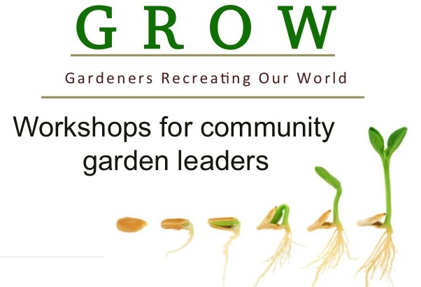
Are you a leader, gardener
or volunteer in a
community, school or
faith-based garden?

Join us for a GROW workshop in Hickory

Saturday October 11, 2014
8:30 AM - 4:00 PM

The workshop will include educational sessions, a networking, lunch and after lunch we will travel to the Hmong Demonstration Garden in Hickory for hands-on demonstrations of season extension techniques and marketing.

- Connect with community gardeners from your region
- Expand your community garden leadership skills
- Learn about pollinators and growing an environmentally-friendly garden
- See season extension in action
- Earn the chance to apply for a mini-grant for your garden

The workshop will be held at the
Catawba County Agricultural Resource Center
1175 S. Brady Ave, Newton, NC
Cost is $15 for NCCGP members, $18 for non-NCCGP members
Visit: www.nccgp.org or GROW-Hickory.eventbrite.com to register
No one will be turned away for a lack of funds, contact the organizers

For more information contact: Maria.Hitt@nccgp.org 919-525-5946
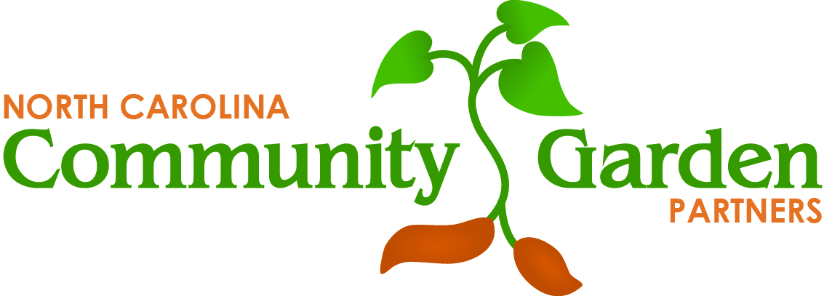
Der Xiong: der_xiong@ncsu.edu 828-465-8248
The GROW workshops are sponsored by NCCGP with funding from:
Burt’s Bees Greater Good Foundation, Resourceful Communities,
a program of The Conservation Fund and Z. Smith Reynolds Foundation We also thank the Catawba County Extension Services for their support.

