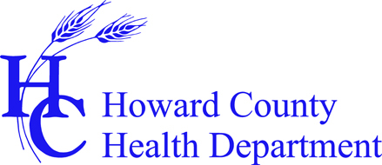

Problem Gambling Prevention & Intervention Training

Training Location: Howard County Health Department

Bureau of Behavioral Health

8930 Stanford Road, Columbia, MD 21045

Speakers: Lori Rugle, Ph.D., Carl Robertson, M.R.E., M.Div

Center of Excellence on Problem Gambling
Mary Ann Warnke, LCADC, Howard County Health Department

Register by calling 410-313-6202 or emailing dhall@howardcountymd.gov
RSVP by June 17, 2014

Tuesday, July 22, 2014  Humphrey Room  Target Audience: teachers, youth advocates, nurses, counselors, social workers, health care professionals, probation and correctional officers, community members concerned/interested in this issue, etc.  Morning: 3 CEUs  9:00 am - noon  Topics include: problem gambling prevalence rates; prevention resources and strategies; and types of gamblers  Lunch on Your Own  Target Audience: counselors, social workers  Afternoon: 3.5 CEUs  1:00 - 4:30 pm  Topics include: DSM V criteria; biology of the brain; integrated approach; and screening of clients for problem gambling |  | Wednesday, August 13, 2014  Room TBA  Target Audience: counselors and social workers  Noon - 4:30 pm 4.5 CEUs  Topics include: integrated problem gambling screening and assessment strategies in at risk groups with co-occurring disorders; brief intervention and motivational approaches; engaging and retaining clients; family and financial management issues; and problem gambling resources
You may participate separately in morning and afternoon sessions and training dates.

