FOR IMMEDIATE RELEASE

UCKI OOD ANNOUNCES 2:365 ART BOOK LAUNCH & EXHIBITION OF PAINTINGS & SCULPTURE
THURSDAY MAY 8, 2014 6:00PM – 12:00AM
EXHIBITION ONLY, MAY 9, 2014 6:00PM – 12:00AM
SOLE REPAIR SHOP
1001 E PIKE ST., SEATTLE, WA 98122

ucki ood, the fine art studio of Missy Douglas & Kim Rask, in partnership with International Bipolar Foundation (IBPF), announces the launch of their new art book, 2:365, and accompanying exhibition of paintings and sculpture. Comprising 365 canvasses painted every day for the entirety of 2013, 2:365 explores the direct relationship between Missy’s struggle with bipolar disorder and her creative voice. Including reproductions of all 365 images and a written diary, the 2:365 Art Book is a stunning, full-color visual record of this tumultuous yearlong journey. All 365 paintings will be exhibited at the launch, as well as recent pieces of sculpture from the ucki ood studio.

About ucki ood

With bases in Seattle and New York City, ucki ood is the fine art studio of artists Missy Douglas & Kim Rask. Highly autobiographical in nature, their paintings and sculpture explore how psychological and emotional trauma is expressed through the physical body. Exploiting both traditional and modern techniques/materials, they are unafraid to lay bare their own personal experiences in order to reveal universal truths and challenge social norms.

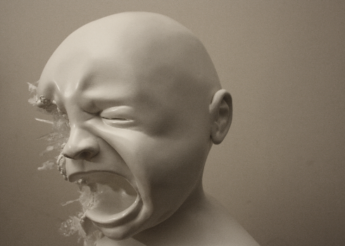
Missy Douglas is a British artist, now residing in the US. A former professor of fine art, she was awarded a Ph.D from the University of Cambridge, UK in 2005, and has worked as a professional artist in the fields of oil painting and sculpture since 1999. A former student of University of Washington, Kim Rask is self-taught artist and Seattle native. He has worked extensively in film, animation and sculpture. They have exhibited both in the US and Europe.

About International Bipolar Foundation

Founded in 2007 by four parents with children affected with bipolar disorder, International Bipolar Foundation is a not for profit organization whose mission is to improve understanding and treatment of bipolar disorder through research; to promote care and support resources for individuals and caregivers; and to erase stigma through education. To learn more, please visit www.ibpf.org.

Registration required, please visit http://bit.ly/1lpy0lA
This is a free event. Appetizers and drinks will be served on May 8.
Press Contact

Kim Rask
1-206-430-3442
kim@uckiood.com
www.uckiood.com
Ashley Jacobs MSW
Director of Operations, International Bipolar Foundation
8895 Towne Centre Drive; Suite 105-360 San Diego, CA 92122
1-858-764-2496 ajacobs@ibpf.org / www.ibpf.org

