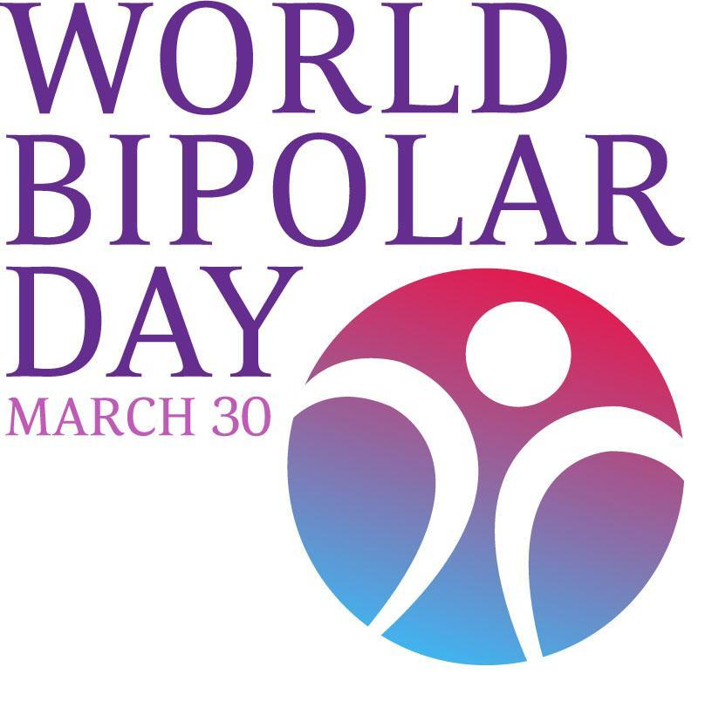
World Bipolar Day - an initiative of the Asian Network of Bipolar Disorder, the International Bipolar Foundation, and the International Society for Bipolar Disorders - will be celebrated each year on March 30th, the birthday of Vincent Van Gogh, who was posthumously diagnosed as probably having bipolar disorder.

The vision of World Bipolar Day is to bring world awareness to bipolar disorders and eliminate social stigma. Through international collaboration, the goal of World Bipolar Day will be to educate the world population about bipolar disorders and help improve sensitivity toward the illness.

Each of the organizations is encouraging their members, chapters and affiliates to orchestrate local events surrounding World Bipolar Day.

International Bipolar Foundation’s CALL TO ACTION:

- We are asking the general public to submit a photo with a message that says “I am … ” and then describe something about you, who you are beyond or behind your illness, such as “I’m am proud to be me” “I am an artist” “I am successful” “I am more than my illness.” Also include your name (optional), and country. See example below.
- Submit images by March 28th to ajacobs@ibpf.org.
- On March 30th images will be displayed on Facebook, Twitter and the International Bipolar Foundation website.

For more information, please visit www.ibpf.org or contact Ashley at ajacobs@ibpf.org.

