APPLICATION
Full Name: Age:
High School: Grade:
Email Address: Phone:
Homes Address:

Spring 2014 English Teacher’s name and email address:

Spring 2014 Art Teacher’s name and email address (if applicable):

Arts Writing Intensive requires perfect attendance: 10am-1pm on April 19th, April 26th, May 3rd, and May 10th. Can you make this commitment?

Do you have reliable internet and computer access?

Do you have reliable transportation?

What is your connection to art and/or writing? (150 words or less)

Why are you interested in participating in this intensive? What do you hope to get out of it? (150 words or less)

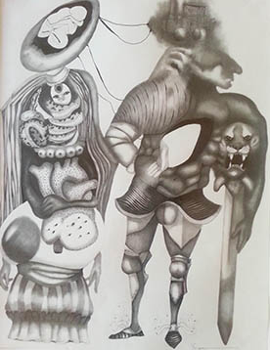
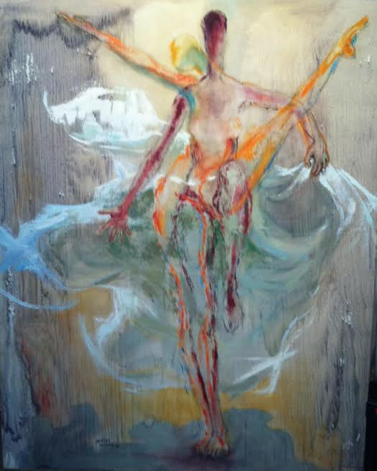
Yanique Norman, Portrait of a Slave Marriage, 2006,
Graphite, Collage and Gouache on Paper

Jenelsie Walden Holloway, Cry, 1977, Oil on Canvas

Image credit: Hammonds House Museum Permanent Collection

Select and respond to one of the above pieces in 300-500 words. Include your response below:

Please submit your application and teacher recommendation letter to Jessie Matheson, Education Director, at jessie@wrensnest.org on or before March 28th, 2014.
For more information, please visit:
burnaway.org hammondshouse.org wrensnest.org

