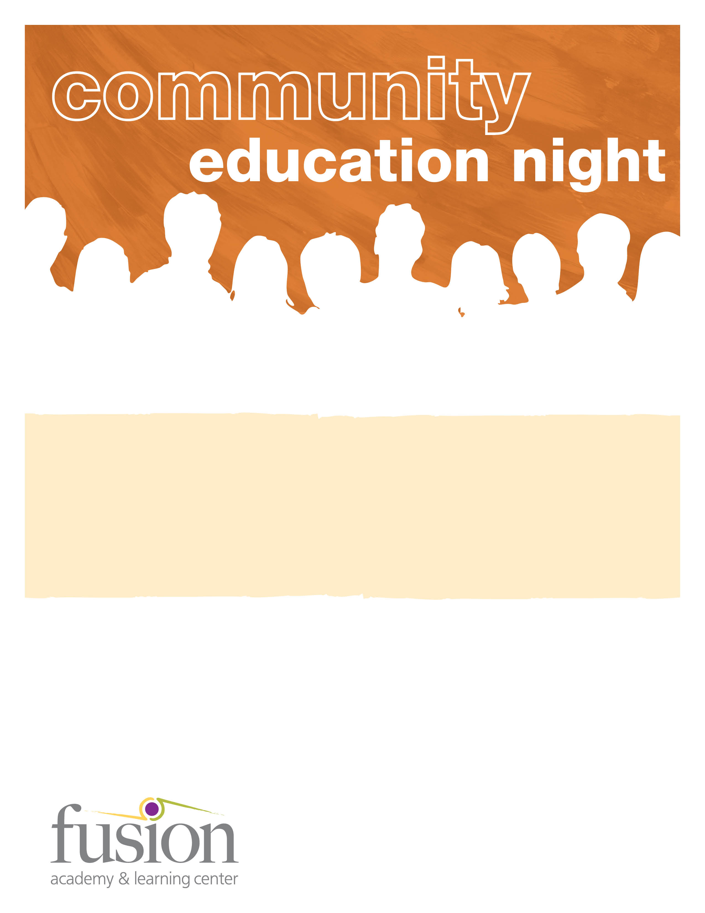

Fusion Academy invites you to join us for an informative and interactive discussion this coming October 22nd. Dr. James Tobin will be leading a discussion about the impact of social media on the emotional and social skills of the current generation of adolescents. He will also be outlining specific parenting strategies to help our teens find a sense of self, something most often lost in the disengaged, broadcasting world of social media.

Dr. Tobin is a licensed psychologist based in Newport Beach, CA who provides individual, couple and family psychotherapy focusing on relationship difficulties and conflicts of identity. He is also an organizational consultant who addresses group dynamics and cultural issues that restrict productivity and creativity in corporate settings.

**To RSVP, please visit www.FusionMissionViejo.com/Events or email agutierrez@fusionacademy.com**

**The Parenting of Adolescents in the 21st Century**

*Presented by* James Tobin, Ph.D.

**Fusion Academy Mission Viejo**

23456 Madero, Suite 140 • Mission Viejo, CA 92691

949.716.7384 • FusionMissionViejo.com

**Tuesday, October 22, 2013**

**6:30-8:00 p.m.**

Fusion Academy Mission Viejo

23456 Madero, Suite 140

Mission Viejo, CA 92691