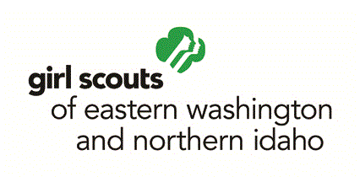
APPLICATION FOR GIRL BOARD PARTICIPANT
GIRL SCOUTS OF EASTERN WASHINGTON AND NORHTERN IDAHO
BOARD OF DIRECTORS

First Name |  | Last Name
Address | City |  | State | Zip Code
Telephone (day) |  | Telephone (evening)
Email Address
Current Grade Level |  | Service Unit Date of Birth

Why are you interested in serving as a Girl Member on the Board of Directors?

Describe three skills or characteristics you possess that would be beneficial for this position.

What leadership positions have you held in Girl Scouting?

What leadership positions or affiliations have you held outside of Girl Scouting?

What do you think Girl Scouting should be doing to meet the needs of today’s girls?

How do you see yourself expressing leadership as a member of the board? Describe a situation where you think you took the initiative.

Are there any special skills or qualities that you would like to share?

Tell us about one of the biggest challenges you have faced and how you overcame it.

Please provide Two (2) References:

Reference One:
Name (first and last) | Title |  | Relationship
Phone |  | Email Address

Reference Two:
Name (first and last) | Title |  | Relationship
Phone |  | Email Address

My racial background is: (please check as many as apply)

- American Indian or Alaskan Native
- Asian
- African American
- Hawaiian or Pacific Islander
- White
My ethnic background is: (please check one)

- Hispanic or Latino
- Not Hispanic or Latino

Submit completed application to snoble@gsewni.org November 1st, 2014 by, or mail to Susan Noble, 1404 N. Ash Street, Spokane WA 99201.

*All Applicants will be notified of whether they have been appointed or not by
December 1st, 2014

