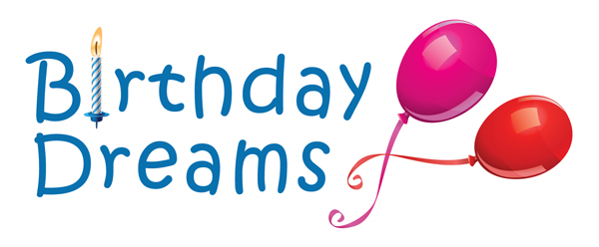

Volunteer Job Description: Grant Writer

Birthday Dreams is a non-profit program dedicated to bringing joy to homeless children with the gift of a birthday party.

Position Description:
- Write and submit grant proposals for new and recurring funding for Birthday Dreams.
- Research new sources of funding that align with Birthday Dreams’ mission and strategies.
- Present new funding opportunities to Executive Director.
- Manage the grant submission calendar and coordinate deadlines with staff/Executive Director.

Skills Required:
- Exceptional organizational, writing and interpersonal communication skills.
- Strong attention to detail and the ability to work independently.
- Ability to prioritize and work well under tight deadlines.
- Experience with Outlook and other Microsoft software.

Qualifications:
- Experience doing intensive research and analyzing data.
- Experience in writing and editing grant proposals.
- Prior experience as a non-profit board member/volunteer or with non-profit donor development is desired.

Hours:
- 3-5 hours per week are ideal. We are flexible and will work with your schedule.
- Working remotely is possibility as long you can occasionally work with staff/Executive Director.
- Office Hours are 9am-5pm, Monday-Friday.
- Attend monthly board meetings as needed.
- Prefer a minimum of a 6-month commitment.

Benefits:
- Use your experience to support creating fun birthday parties for homeless children.
- Contribute to public awareness about disadvantaged children and their families.
- Work behind the scenes to ensure children can celebrate their special day.

Work Site Location:
- Birthday Dreams Office: 1101 Bronson Way N., Renton, WA 98057.

How to Apply:
- Go to www.birthdaydreams.org to learn more about the organization and its volunteer program or call: (425) 988-3954.
- Apply online or indicate an interest in the position by sending an email to: volunteer@birthdaydreams.org

Reports To:
- Executive Director

Additional Info:
- Criminal background check is required.
- Signing a Confidentiality Agreement is required.
- Must be at least age 18.

